Verilog Platform Used: iverilog

Waveform Viewer: Scansion

Operating System: MacOS Sierra 10.13

Kanika Gera

h20180041@goa.bits-pilani.ac.in

2018H1030041G

Advance Computer Architecture Assignment-1

Implementation Assumptions:

1. Instructions are executed are written in Instruction Memory module at specified location.
2. Default Values to some Registers are set

(for executing the add instructions as first instruction)

Default Values of Registers are set as:

Reg [0] = 8, Reg [1] = 7, Reg [2] = 4, Reg [3] = 3, Reg [7] = 8, Reg [15] = 100

1. PC module is implemented as part of top module – mips_32
2. PC is initialized with value 4.

1. **Add** 
   1. Instruction : 32'b100000_00000_00001_00100_00010_xxxxxx;
   2. Output :

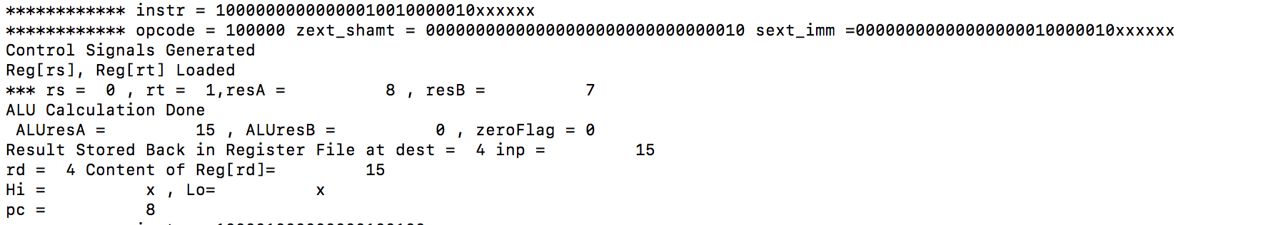

* 1. Waveform:

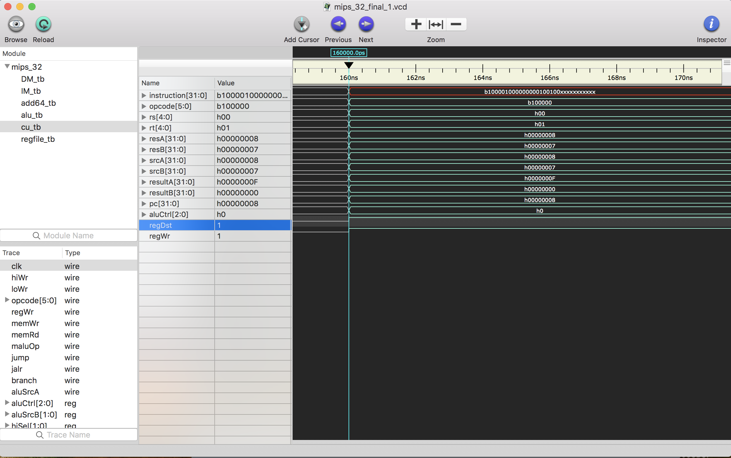

1. **Sub** 
   1. Instruction : 32'b100001_00000_00001_00100_xxxxxxxxxxx;
   2. Output : 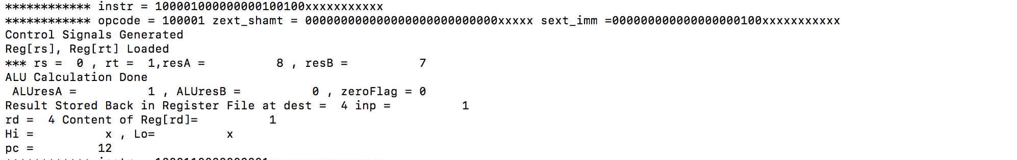
   3. Waveform:

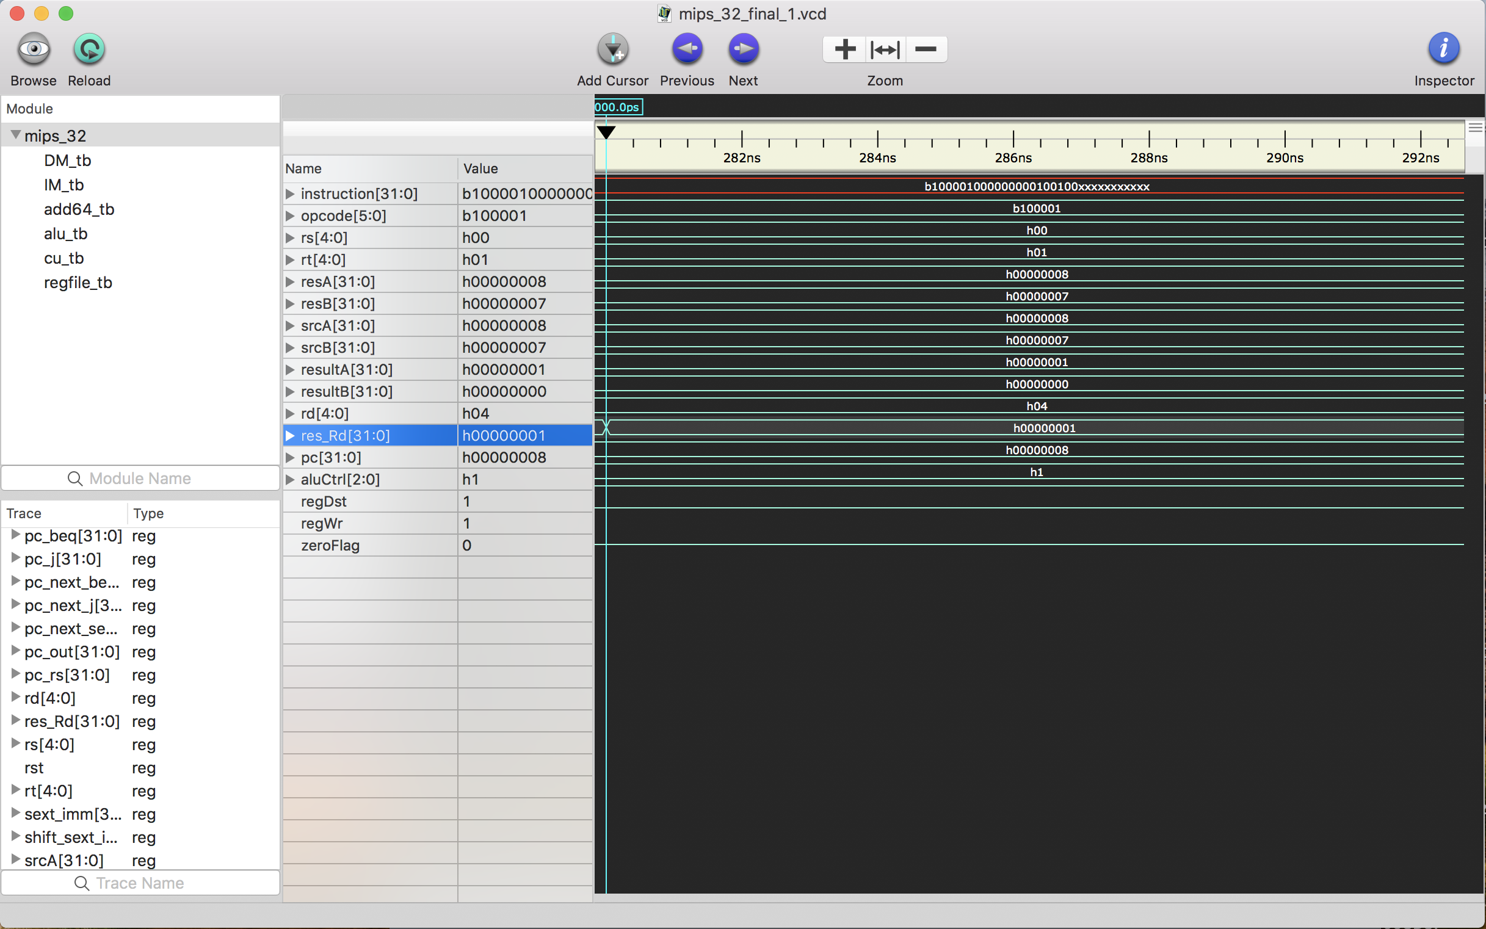

1. **Div** 
   1. Instruction : 32'b100011_00000_00001_xxxxx_xxxxxxxxxxx;
   2. Output : 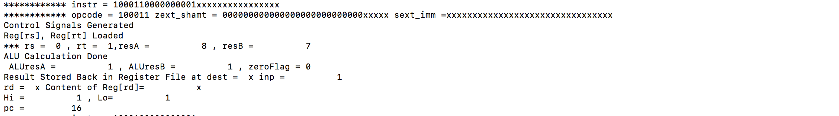
   3. Waveform:

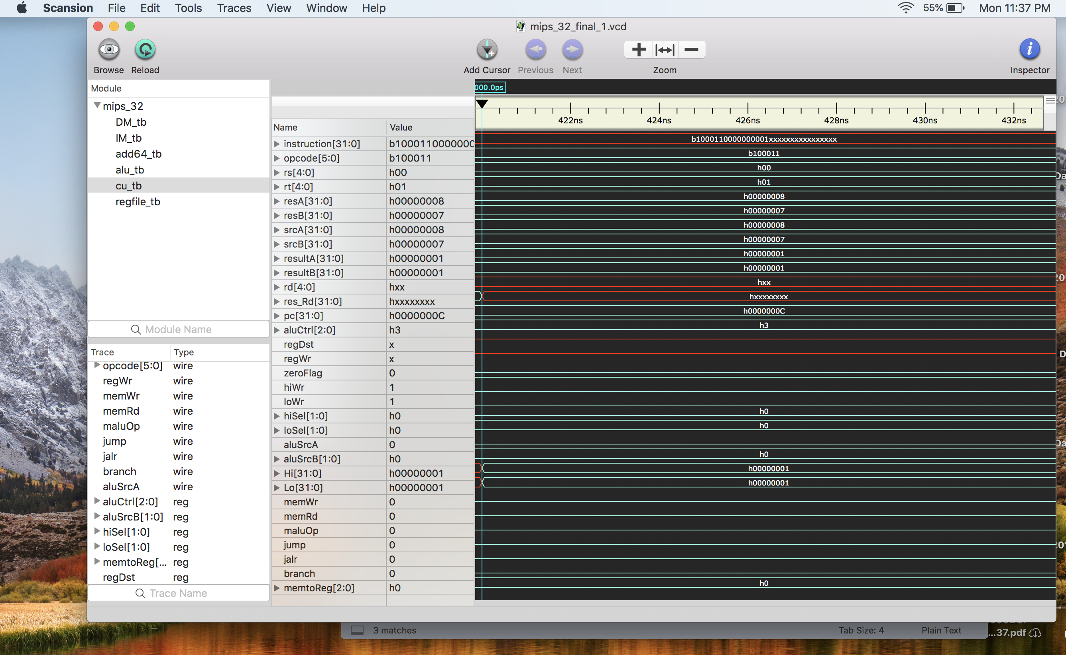

1. **Mul**
   1. Instruction : 32'b100010_00000_00001_xxxxx_xxxxxxxxxxx;
   2. Output :

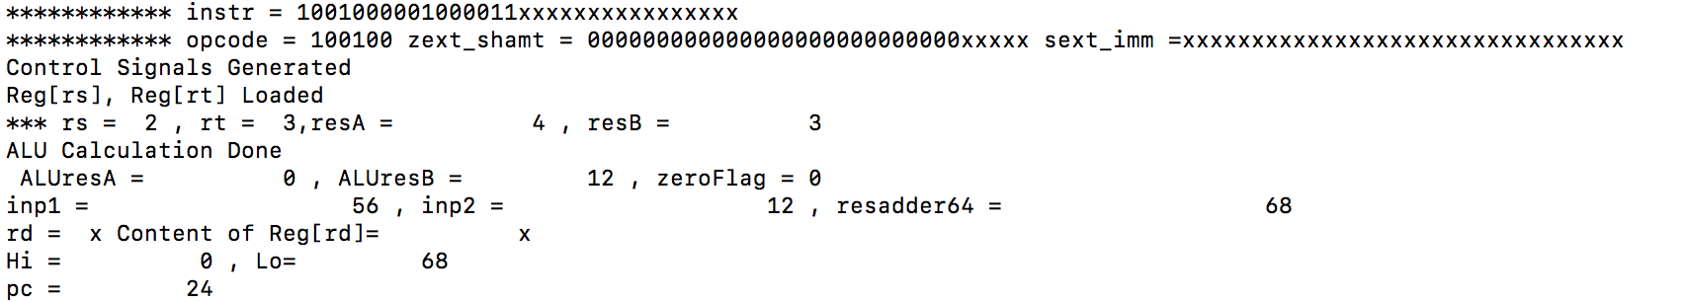

* 1. Waveform:

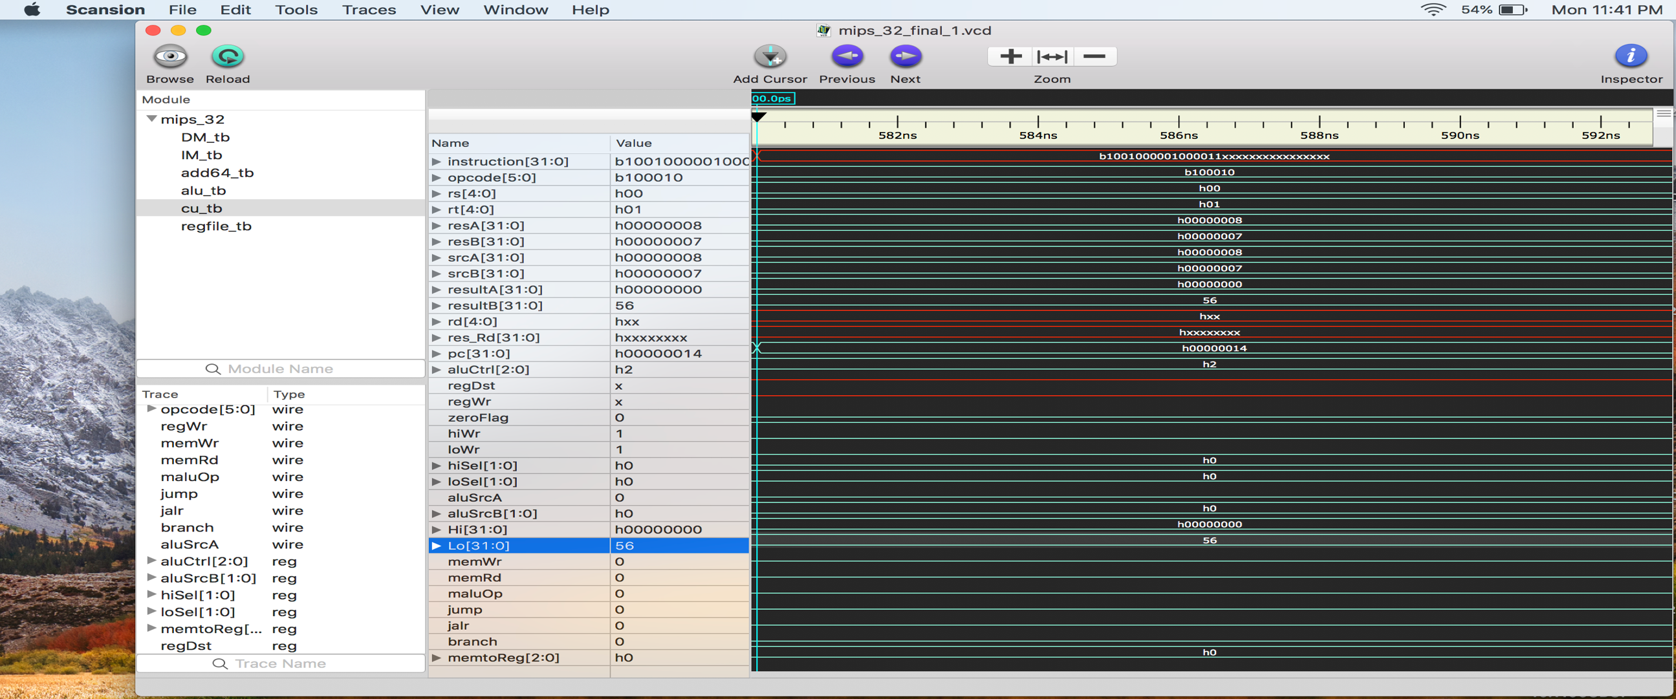

1. **madd** 
   1. Instruction : 32'b100100_00010_00011_xxxxx_xxxxxxxxxxx;
   2. Output :

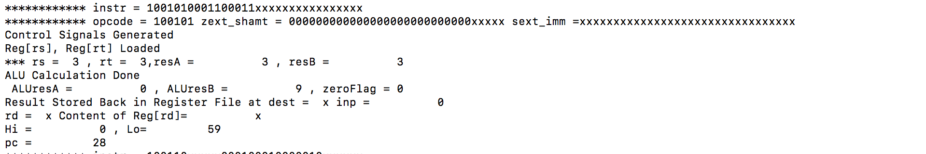

* 1. Waveform:

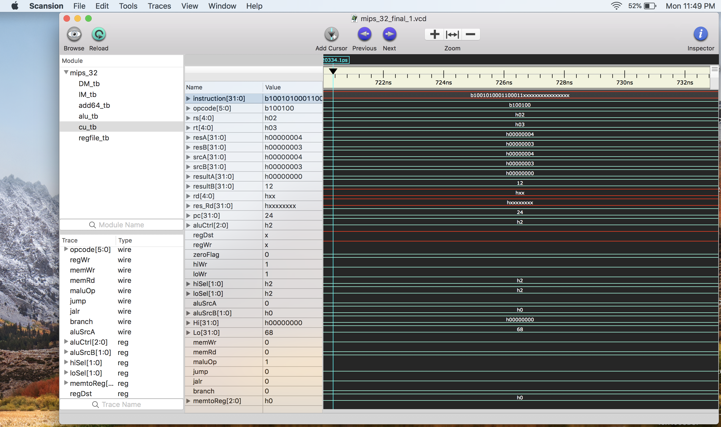

1. **msub** 
   1. Instruction : 32'b100101_00011_00011_xxxxx_xxxxxxxxxxx;
   2. Output :

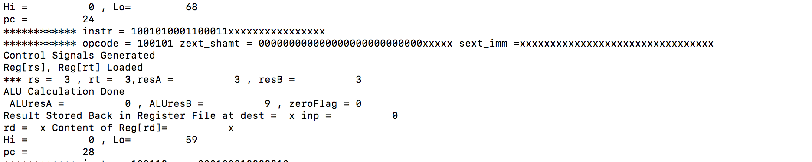

* 1. Waveform:

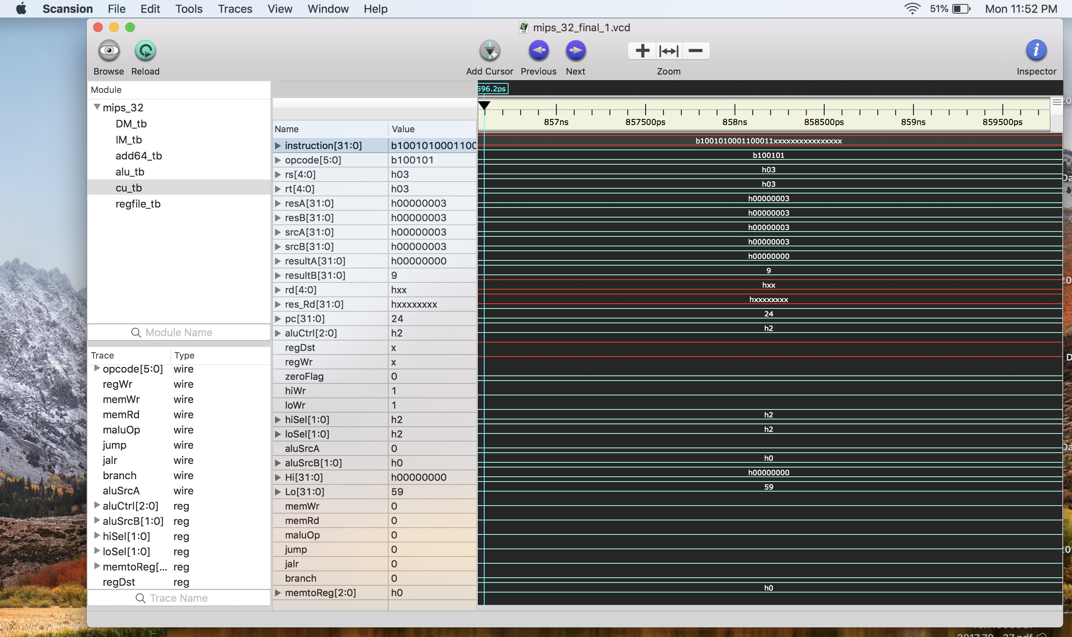

1. **Sll** 
   1. Instruction : 32'b100110_xxxxx_00010_00100_00010_xxxxxx;
   2. Output :

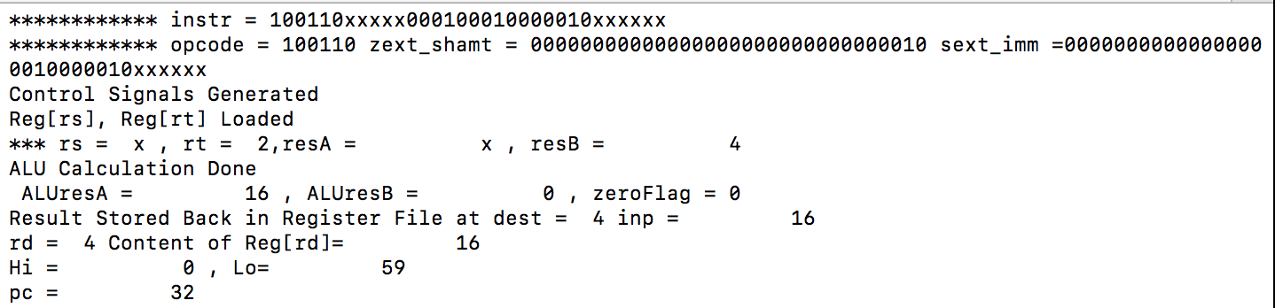

* 1. Waveform:

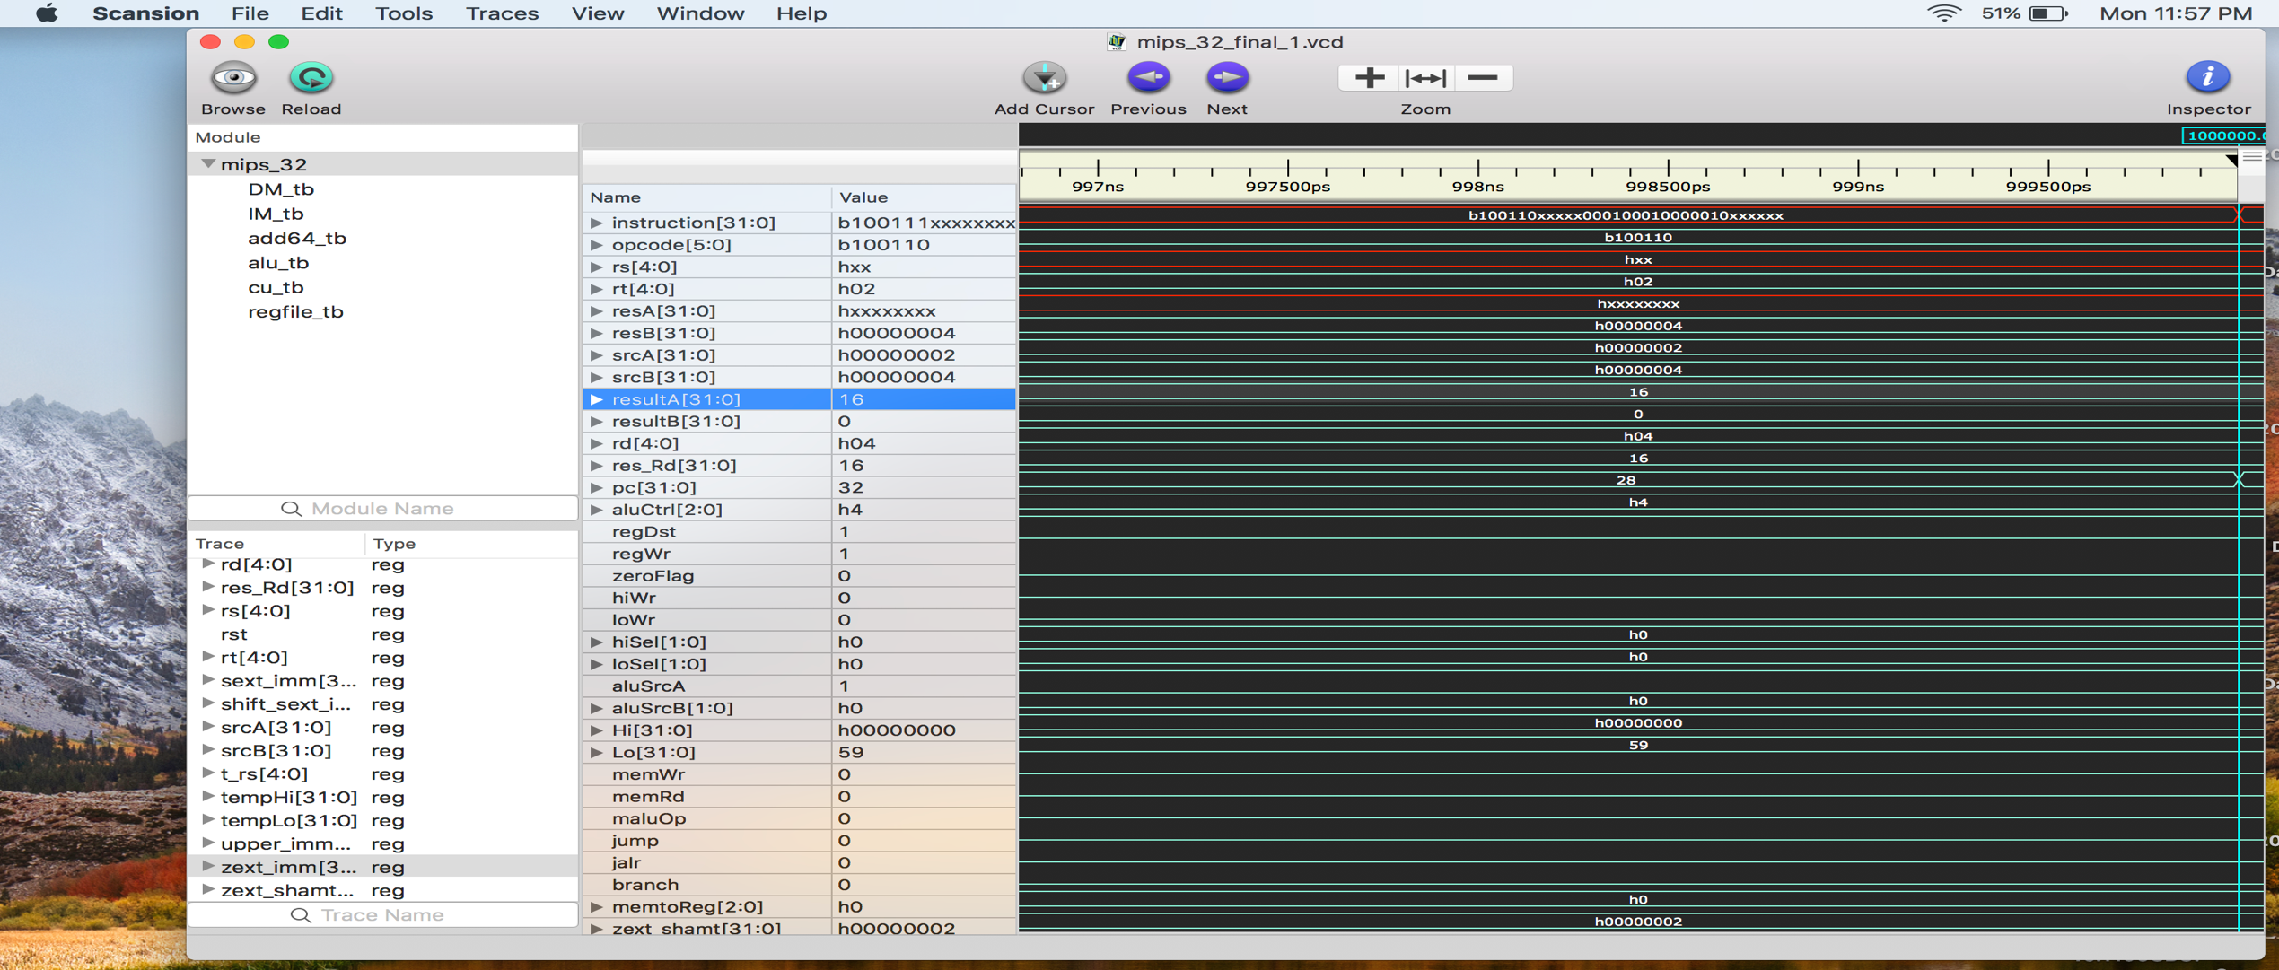

1. **mfhi** 
   1. Instruction b100111_xxxxx_xxxxx_00100_xxxxx_xxxxxx;
   2. Output :

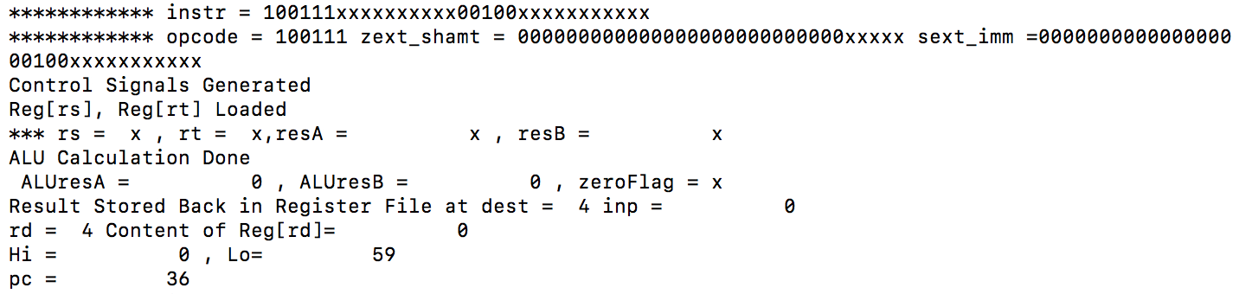

* 1. Waveform:

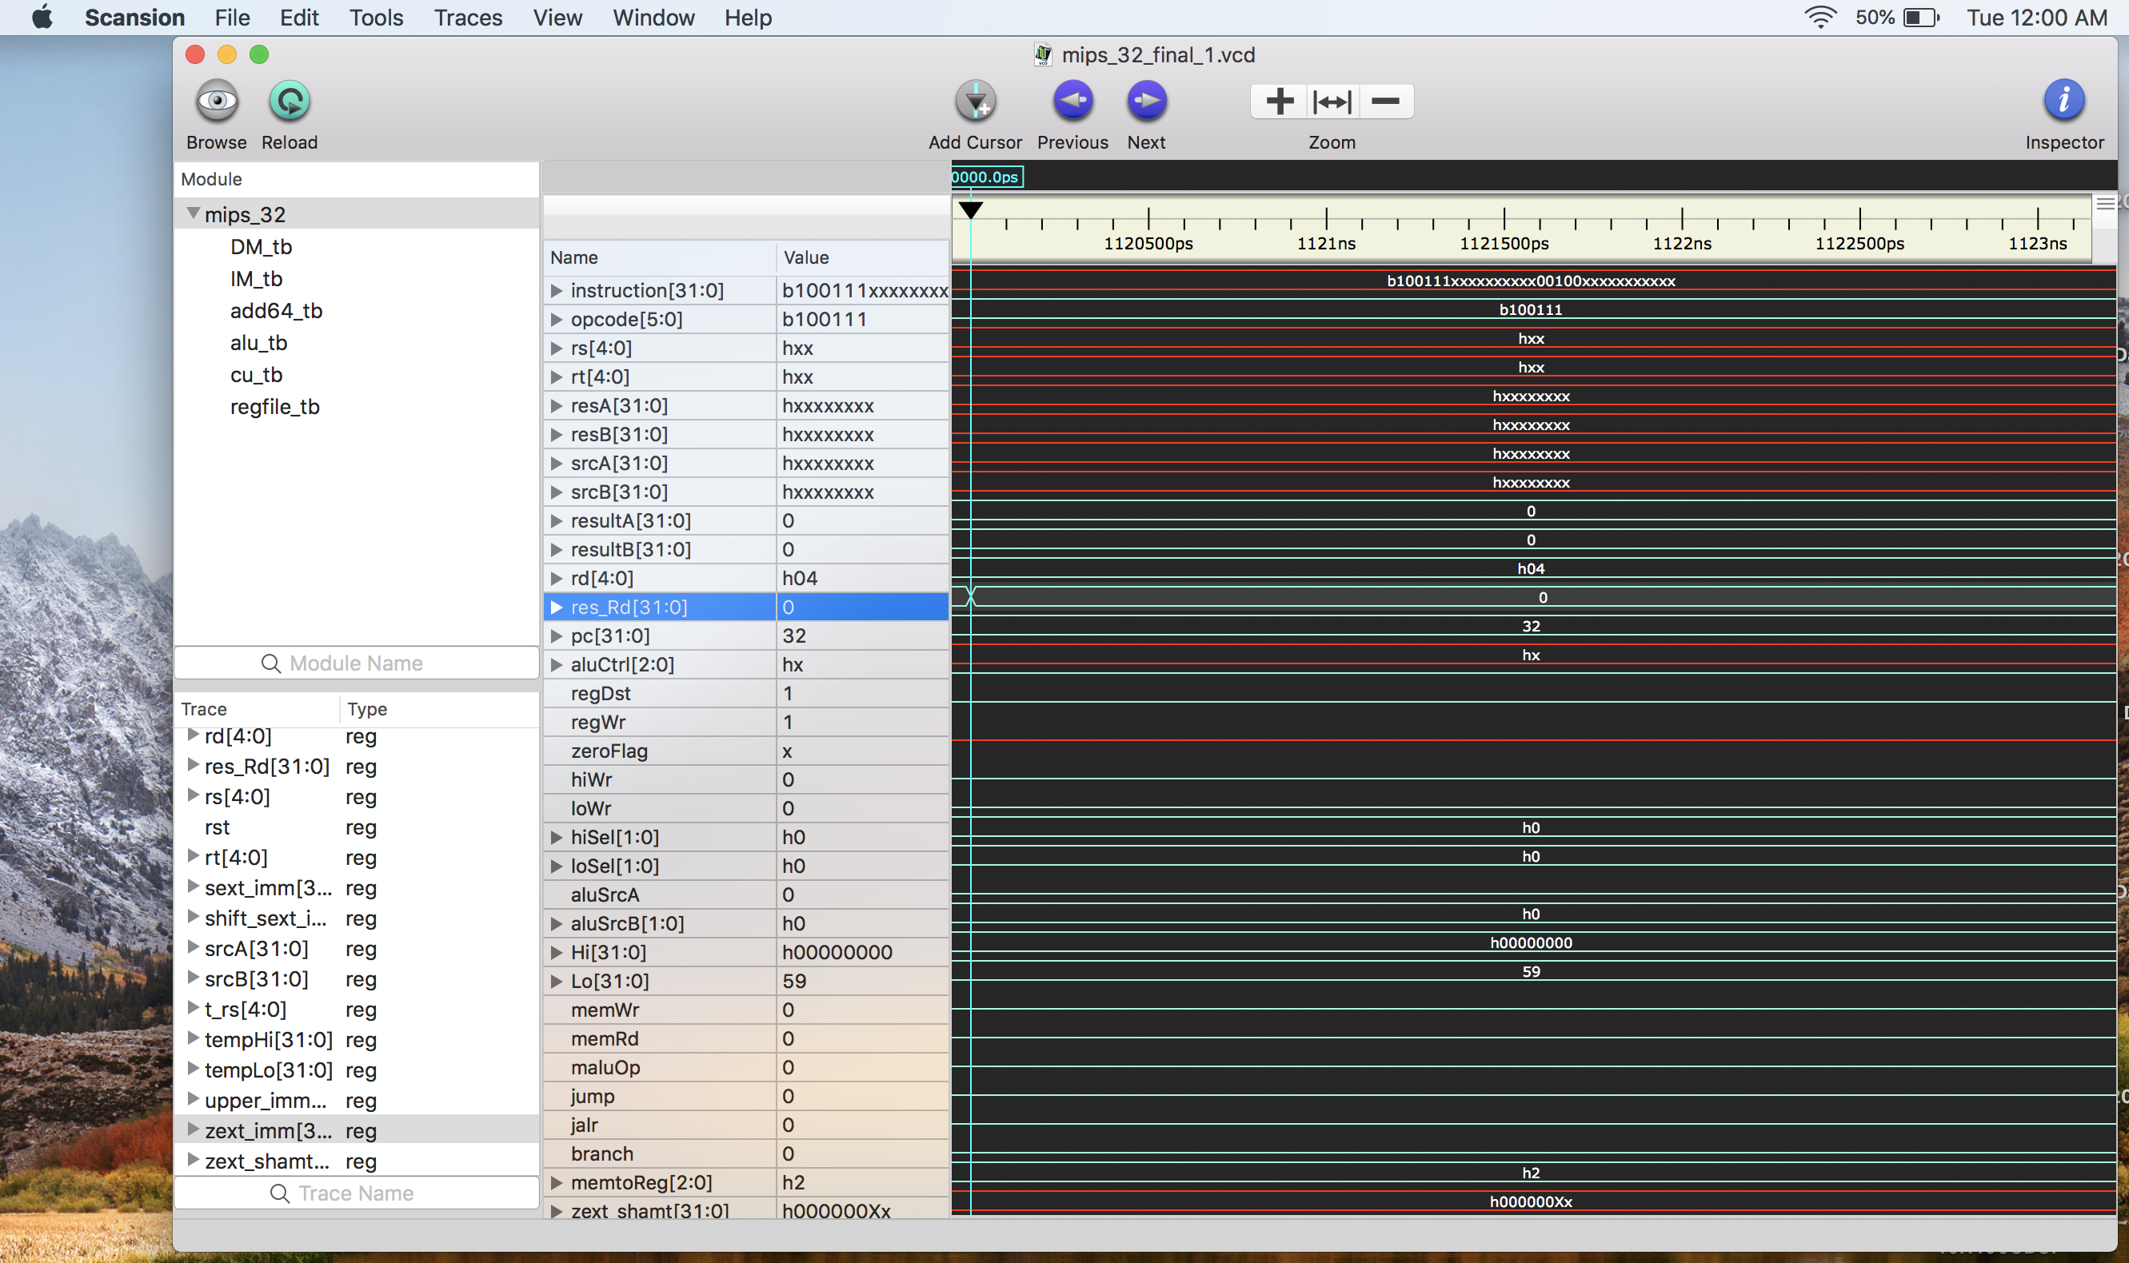

1. **mflo** 
   1. Instruction : 32'b101000_xxxxx_xxxxx_00100_xxxxx_xxxxxx;
   2. Output :

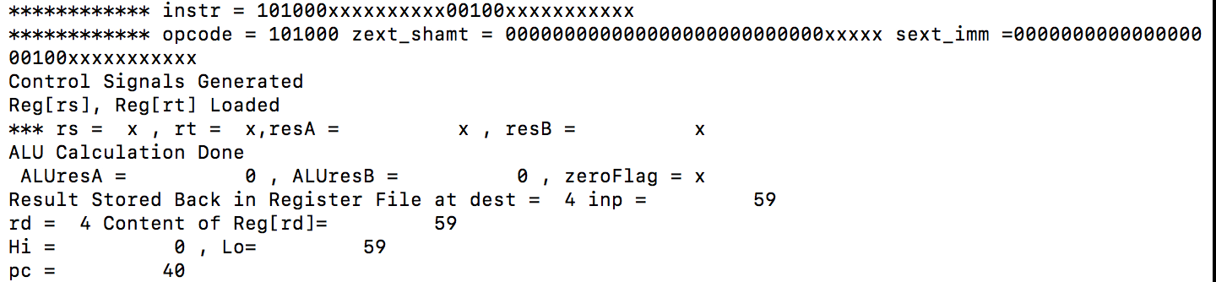

* 1. Waveform:

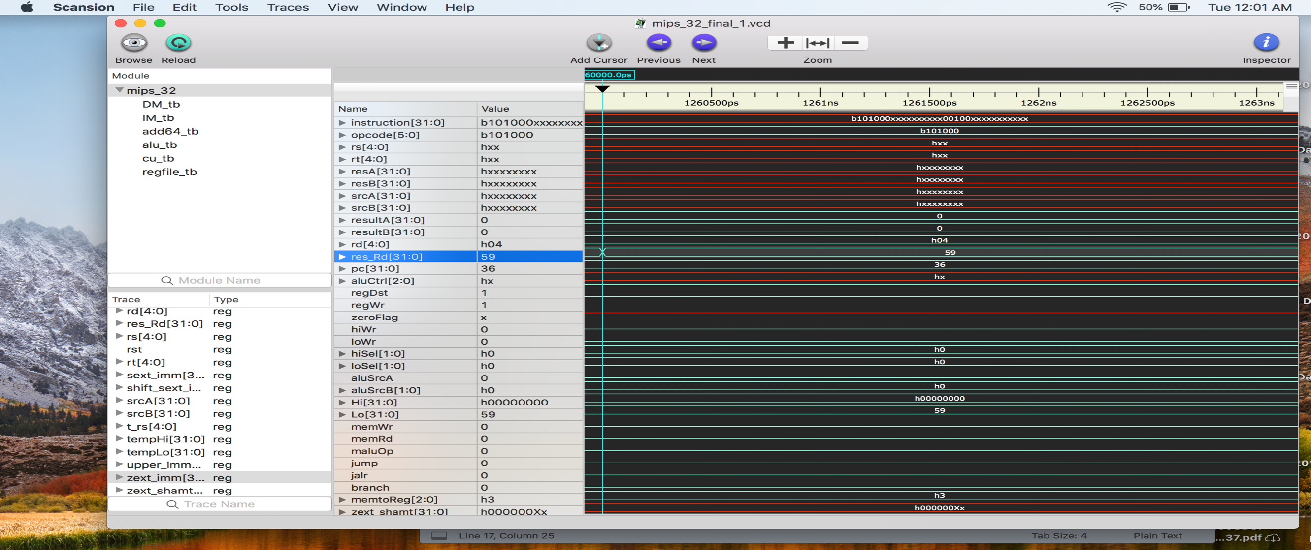

1. **mthi**
   1. Instruction : 32'b101001_00000_xxxxx_xxxxx_xxxxx_xxxxxx;
   2. Output : 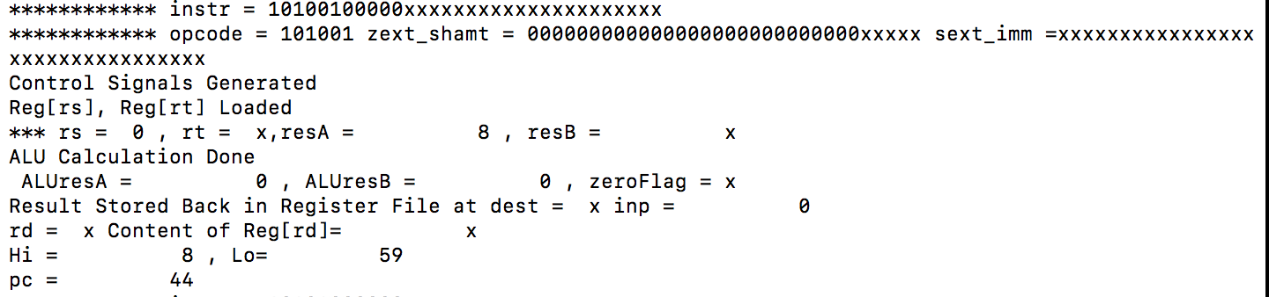

* 1. Waveform:

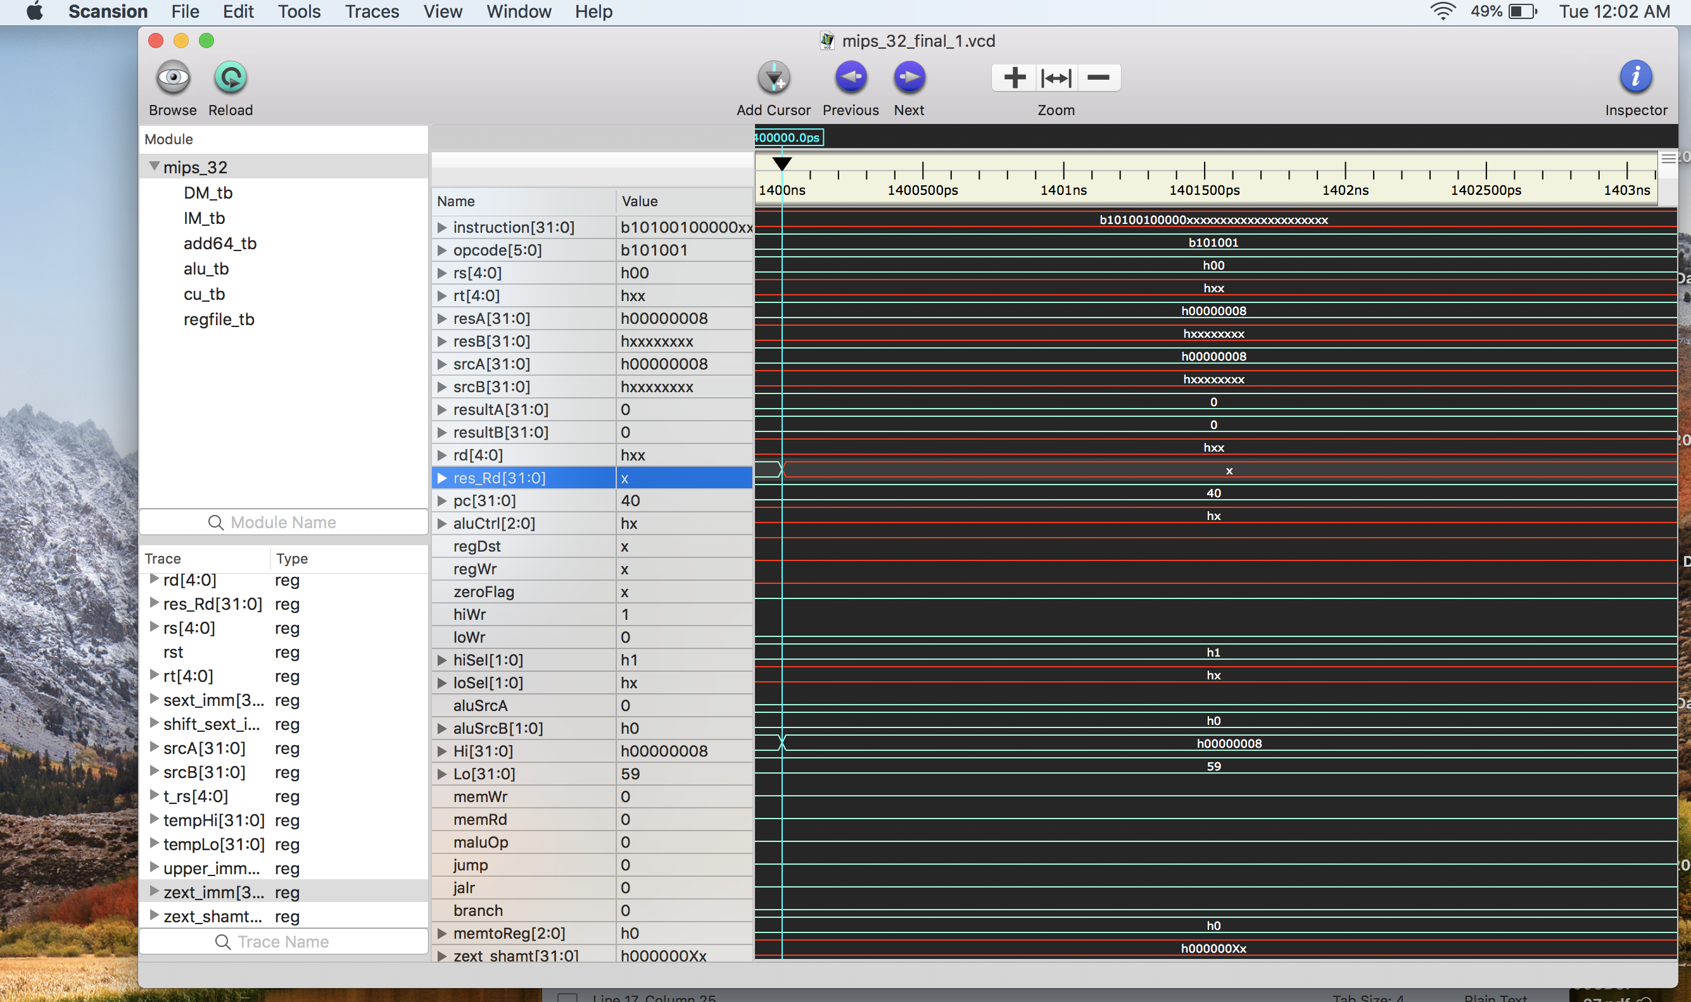

1. **mtlo** 
   1. Instruction : 32'b101010_00000_xxxxx_xxxxx_xxxxx_xxxxxx;
   2. Output :

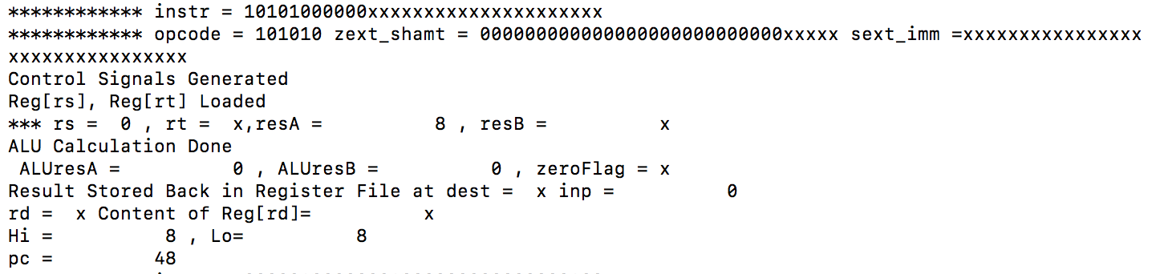

* 1. Waveform:

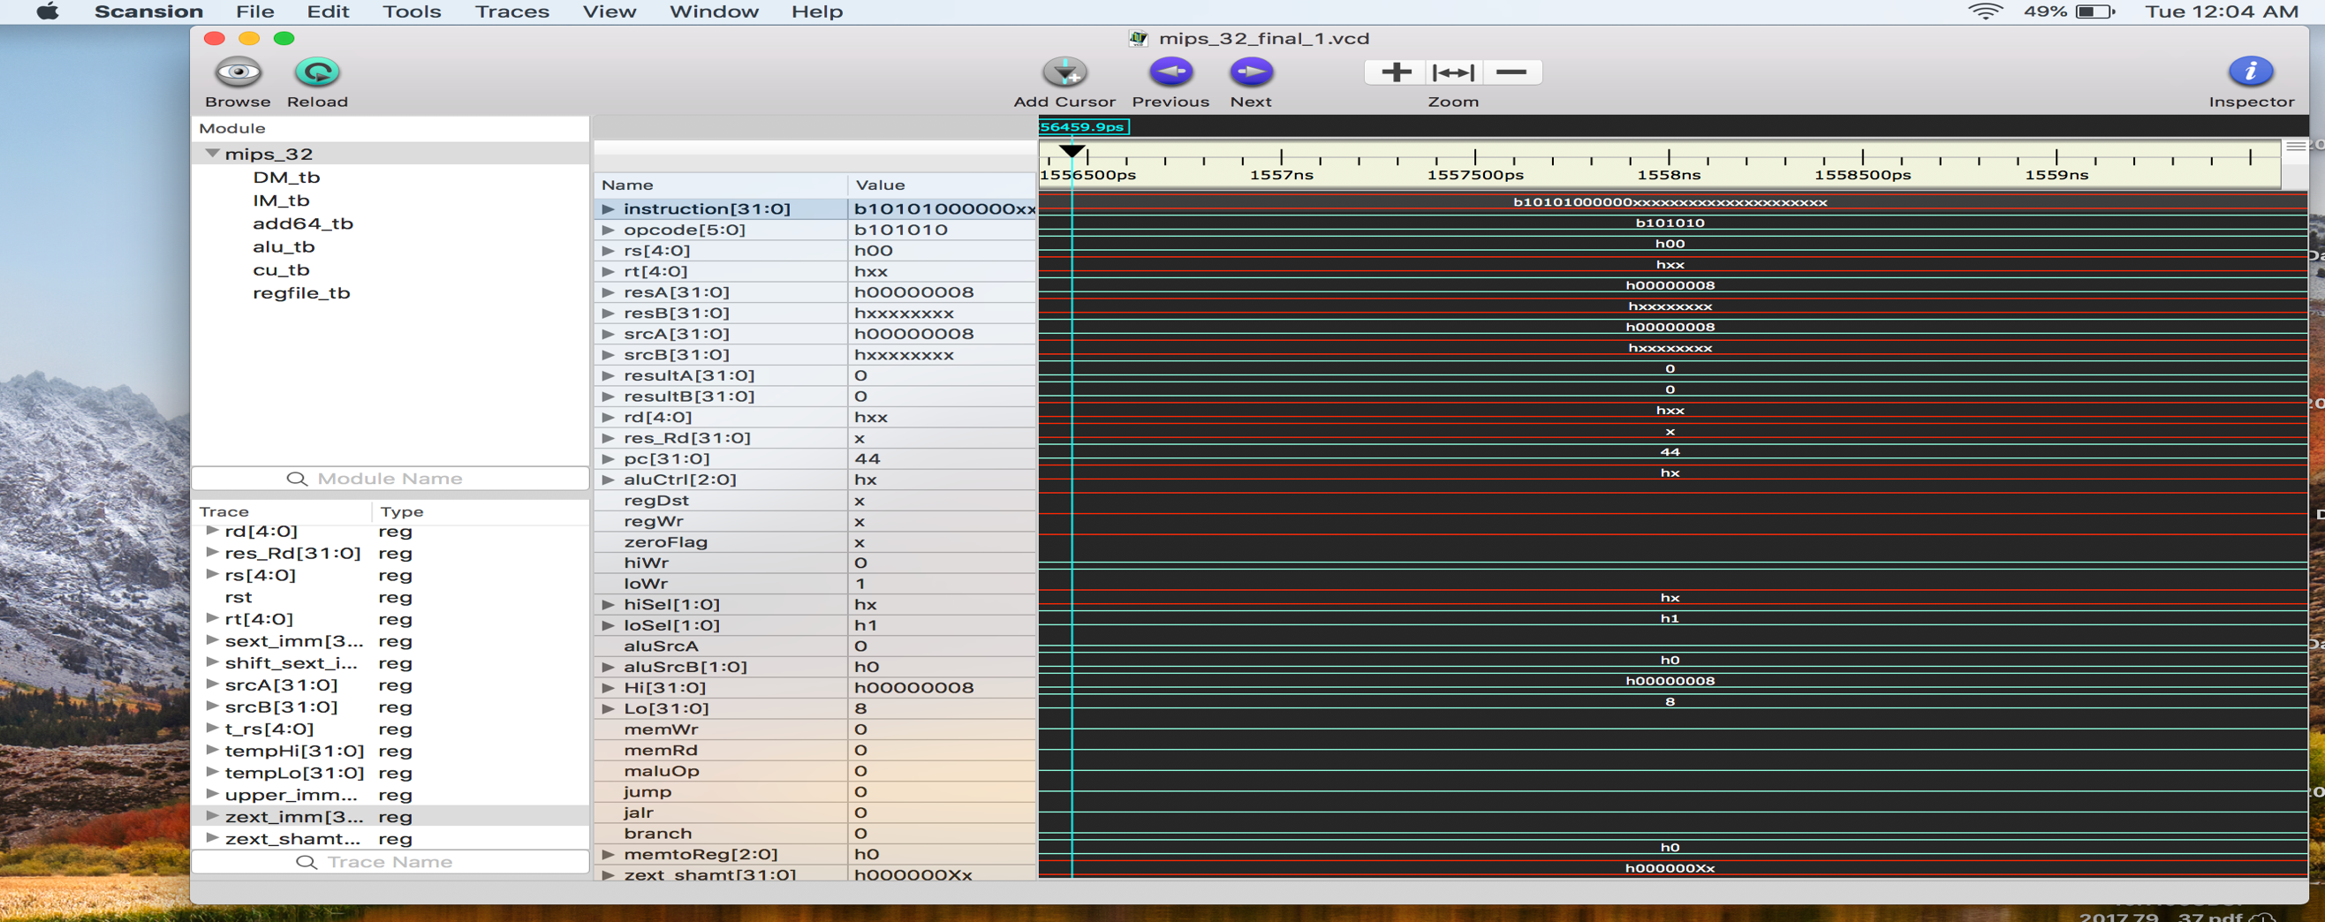

1. **Addi**
   1. Instruction : 32'b000001_00000_00100_00000_00000_000100; // rs =0 rt =4 imm = 4
   2. Output :

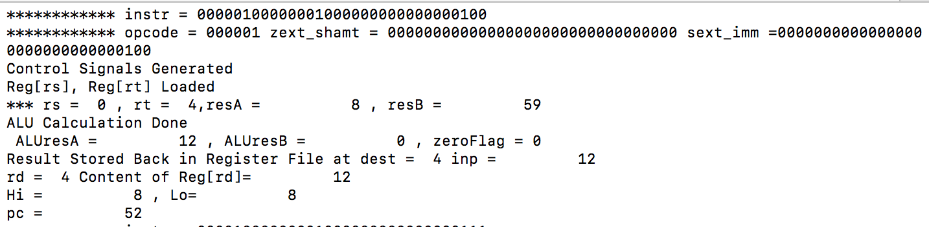

* 1. Waveforms:

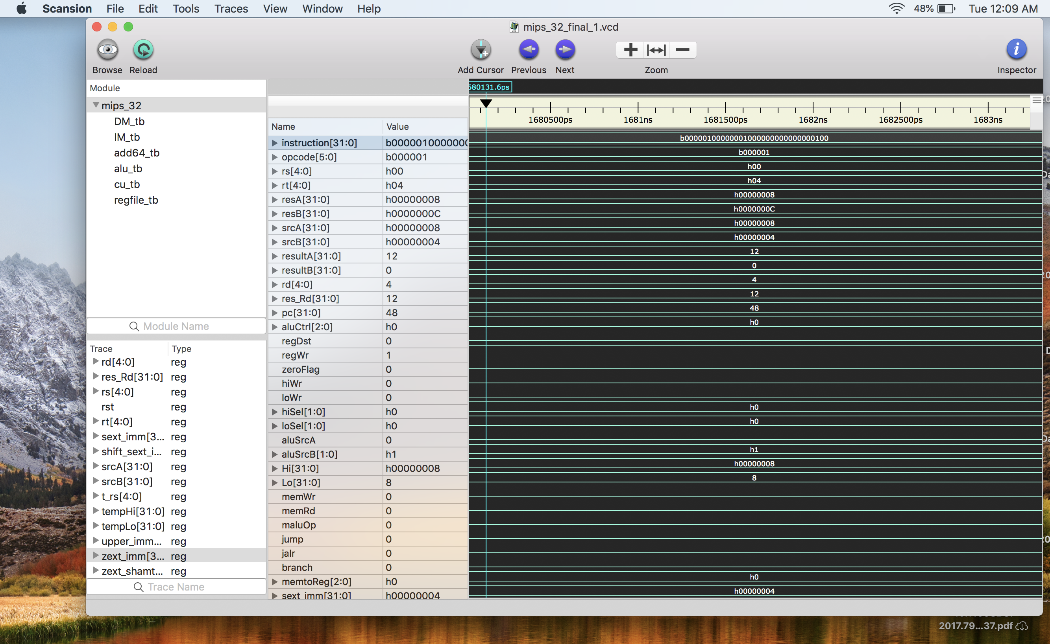

1. **Ori**
   1. Instruction : 32'b000010_00000_00100_00000_00000_000111;
   2. Output :

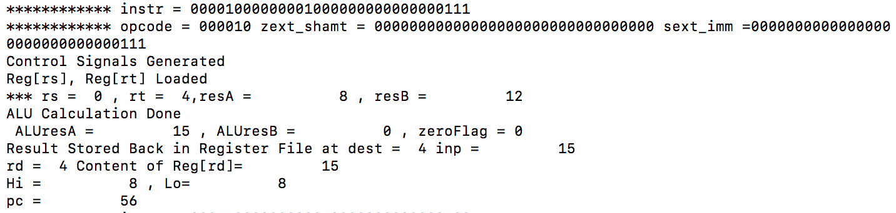

* 1. Waveforms:

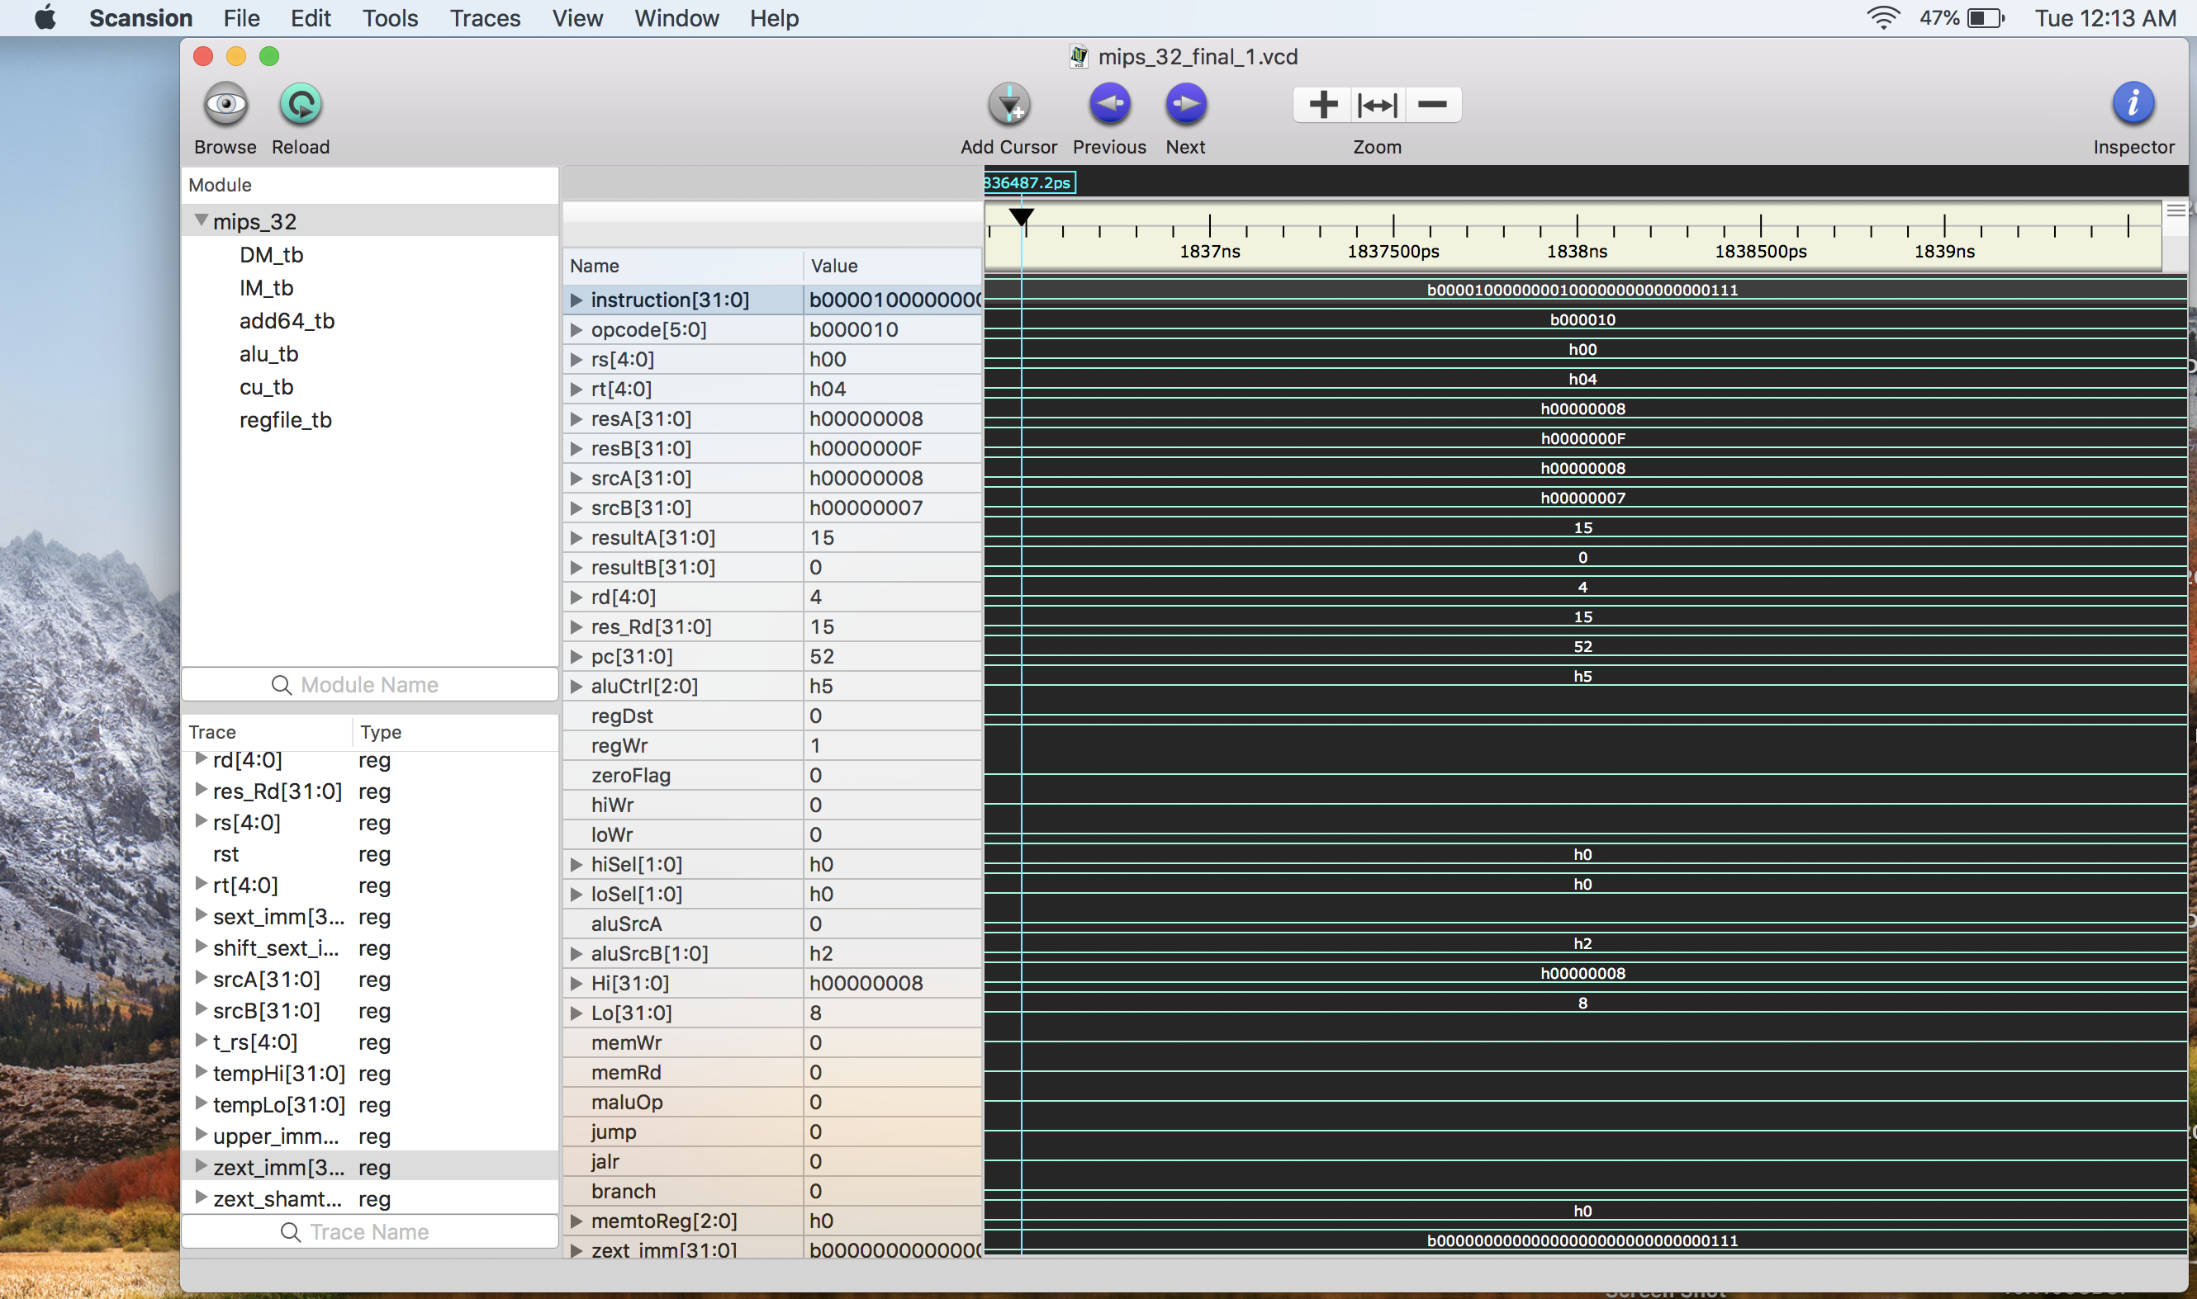

1. **Sw**
   1. Instruction 32'b000110_00000_00001_00000_00000_000100; // store Reg[rt] at Reg[rs]+sext(Imm)
   2. Output :

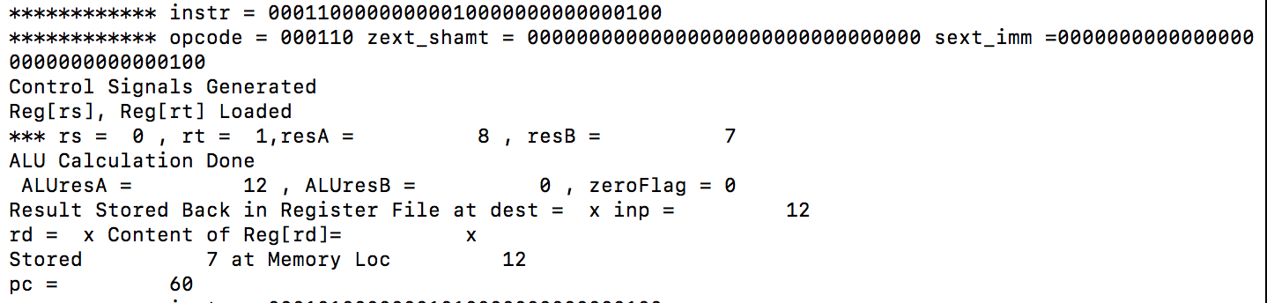

* 1. Waveforms:

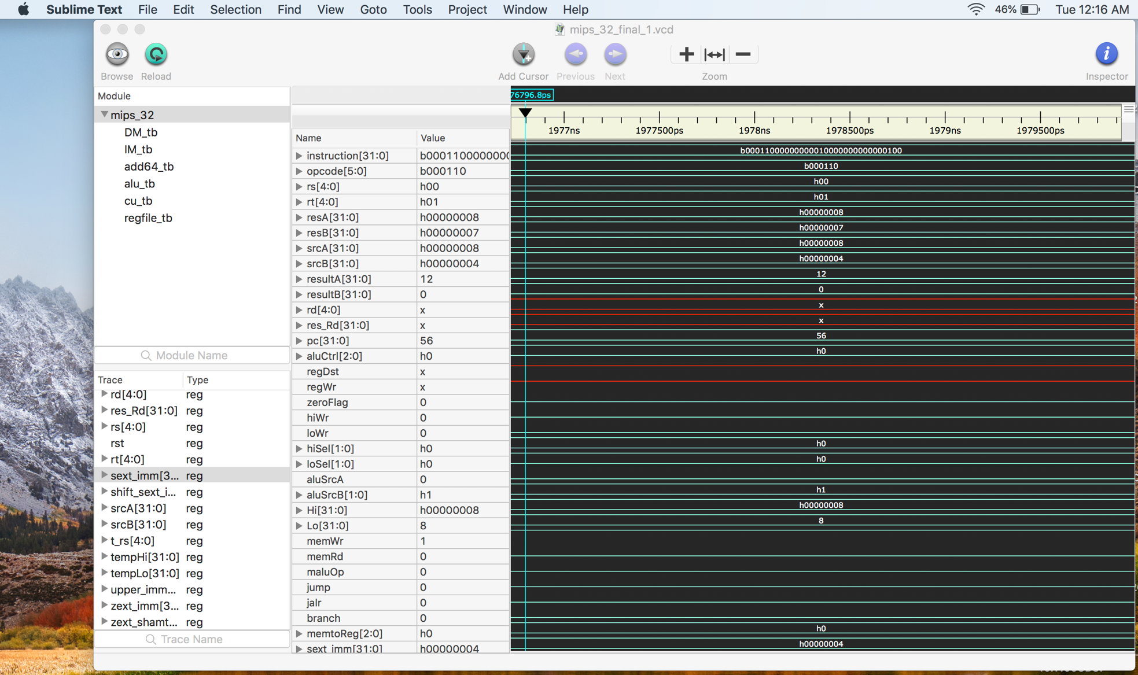

1. **Lw**
   1. Instruction : 32'b000101_00000_00101_00000_00000_000100; // load Reg[rs]+sext(Imm) at rt
   2. Output :

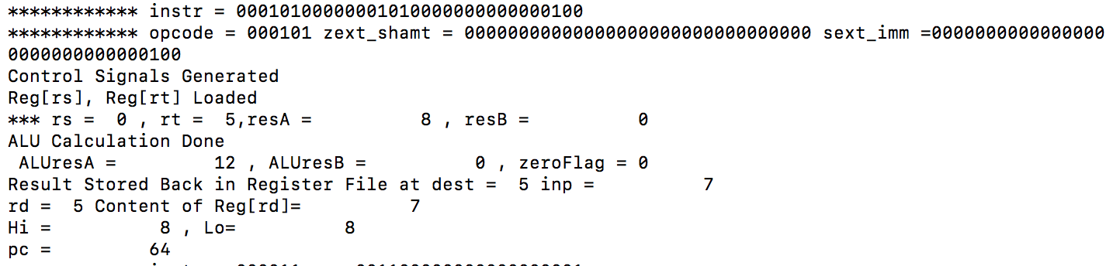

* 1. Waveforms:

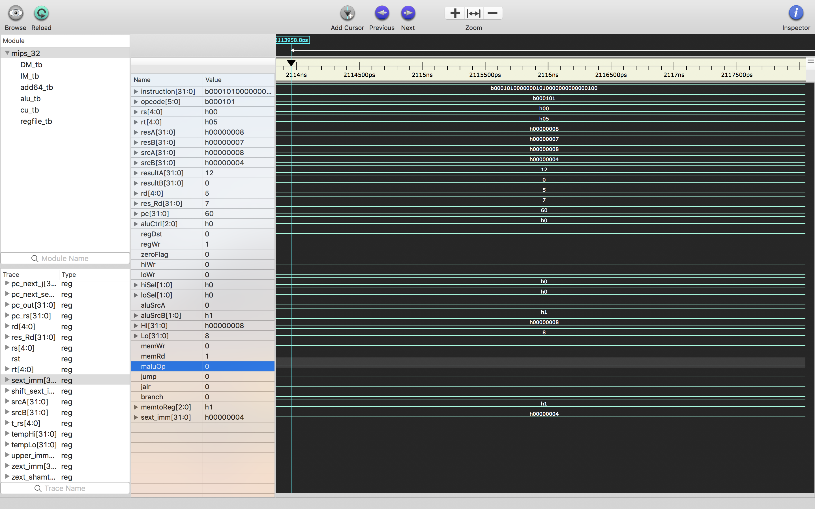

1. **Lui**
   1. Instruction : 32'b000011_xxxxx_00110_00000_00000_000001;
   2. Output :

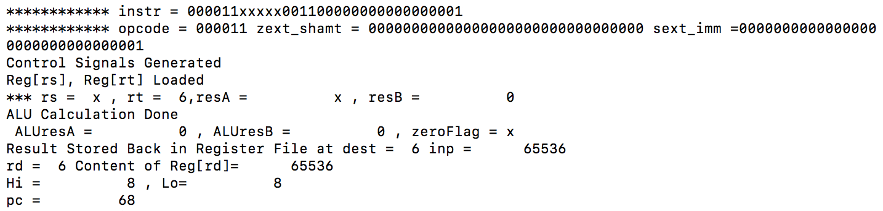

* 1. Waveforms

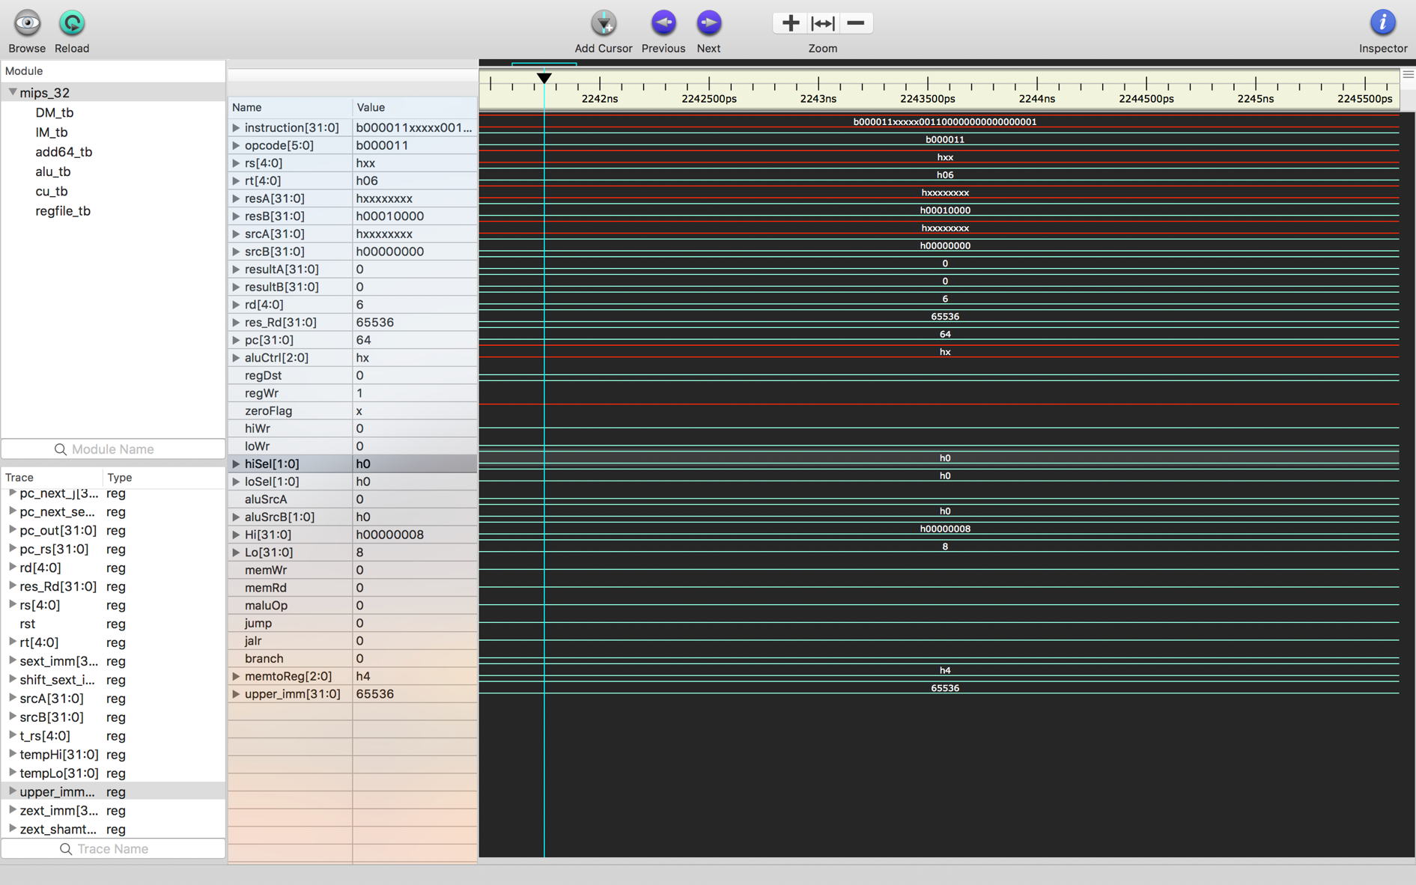

1. **Beq ( branch taken)**
   1. Instruction : 32'b000100_00000_00111_00000_00000_000010;
   2. Output :

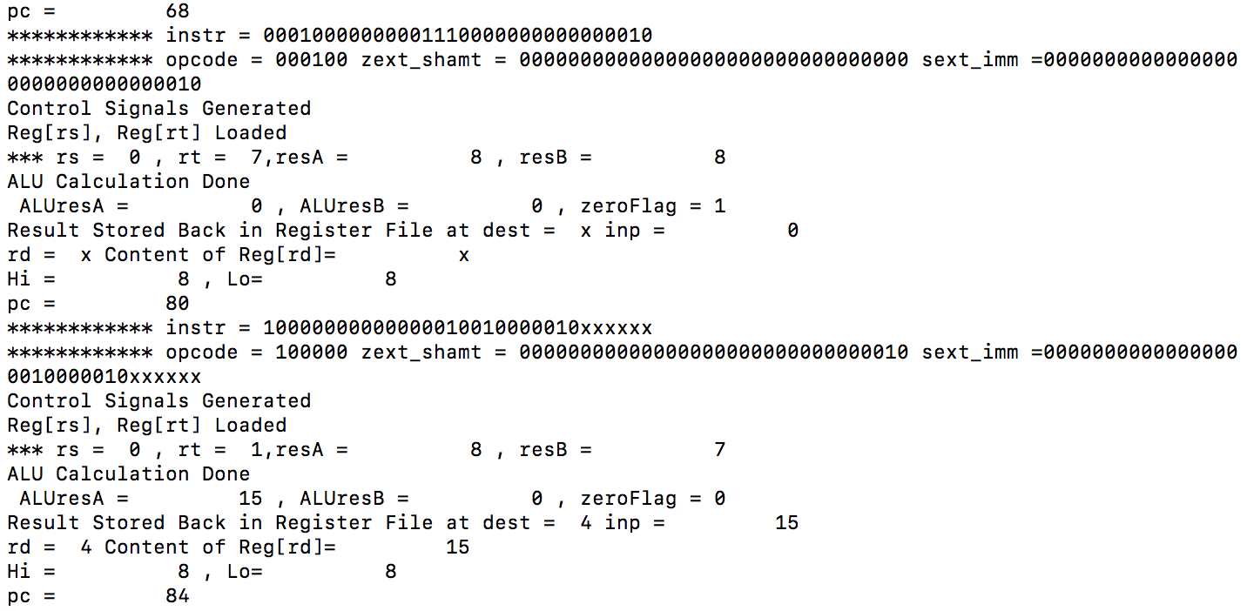

* 1. Waveforms

(next page)

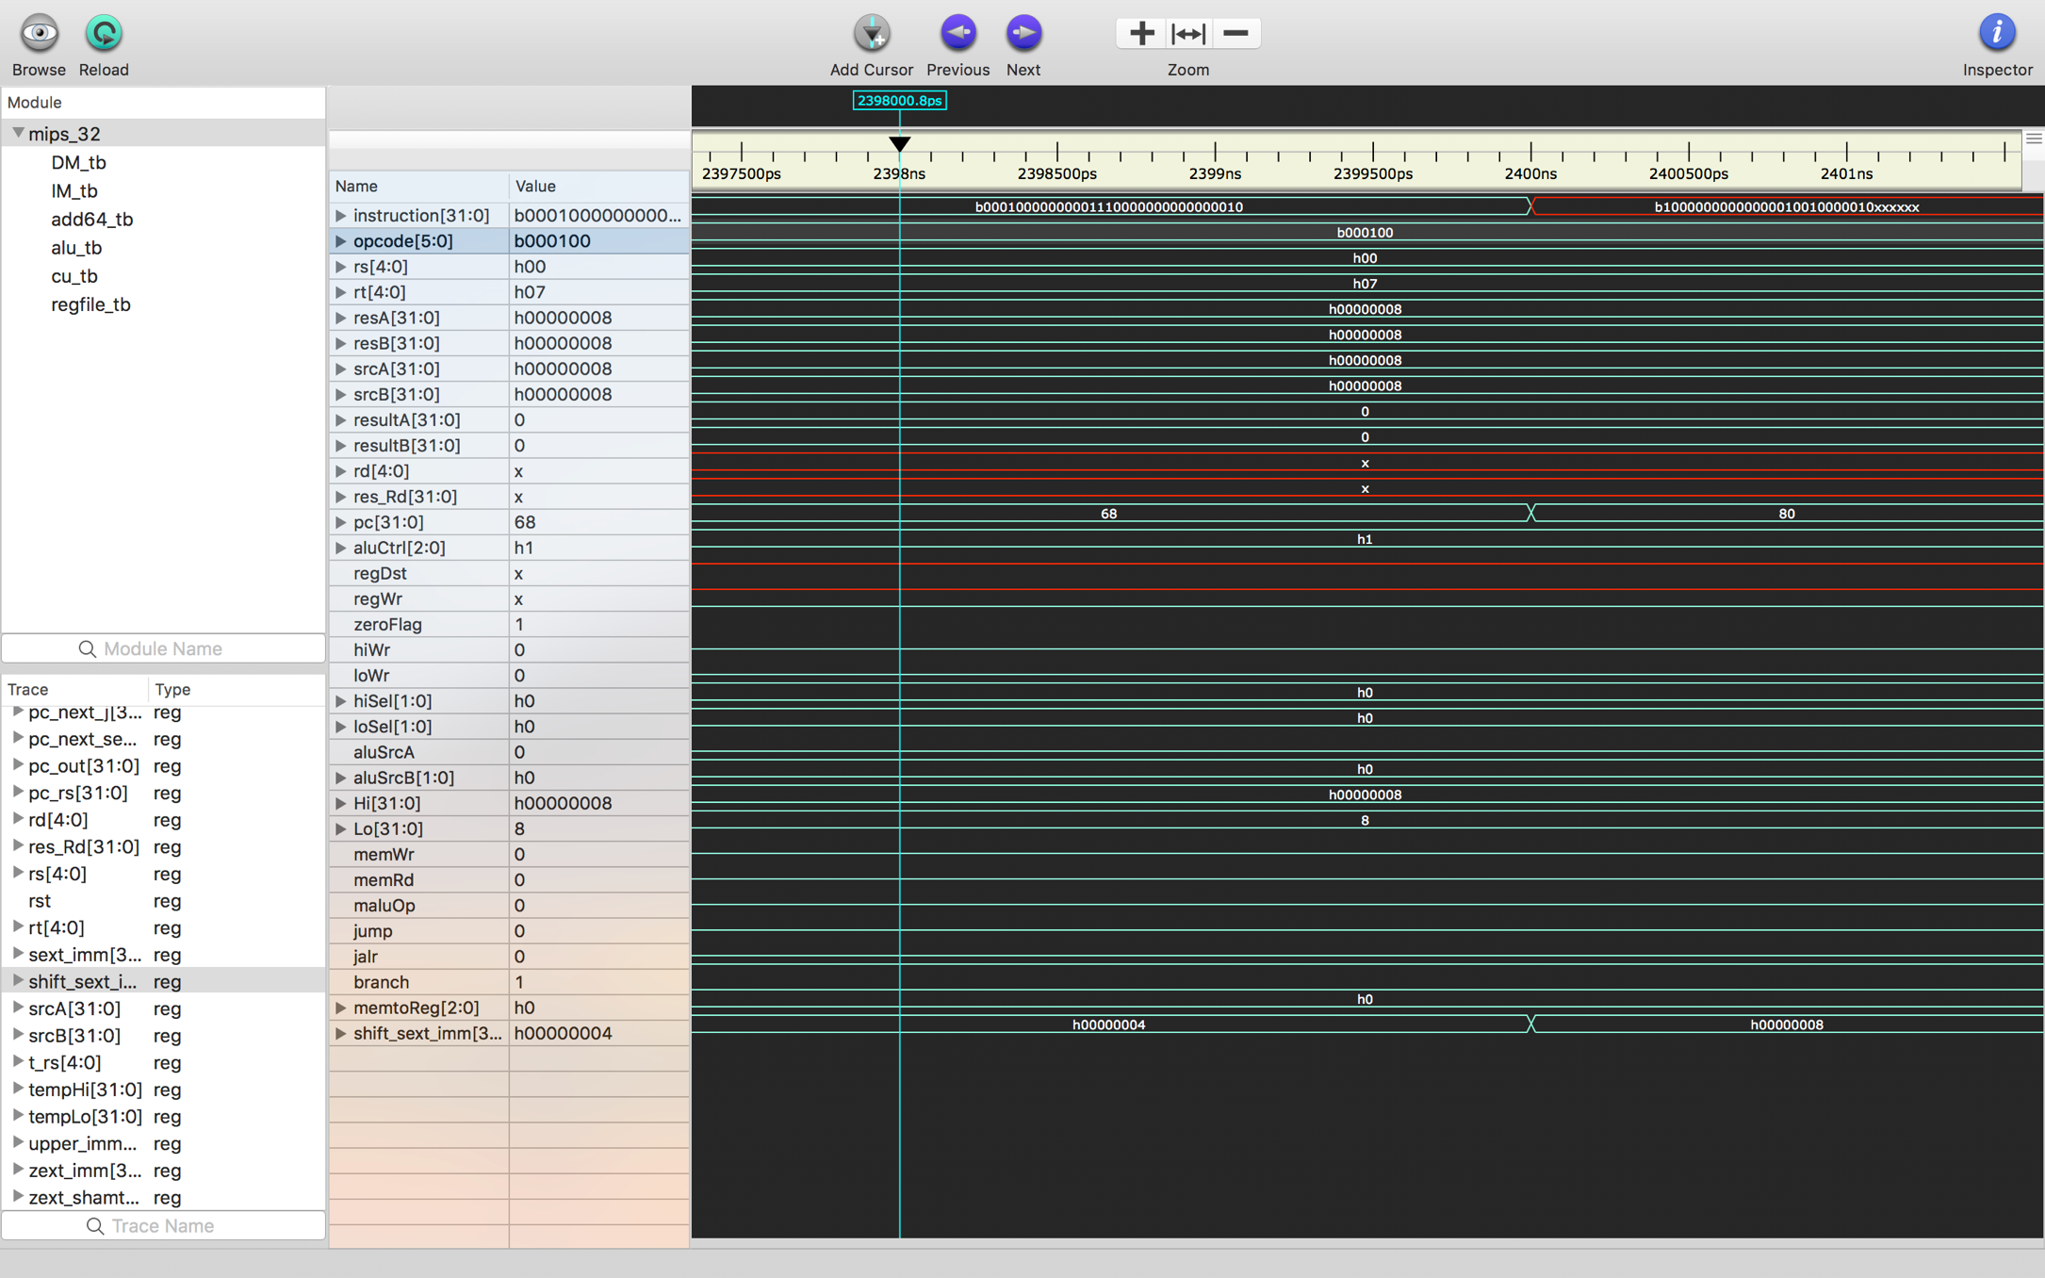

1. *Instruction when beq taken – add*
   1. Instruction : 32'b100000_00000_00001_00100_00010_xxxxxx;
   2. Waveforms

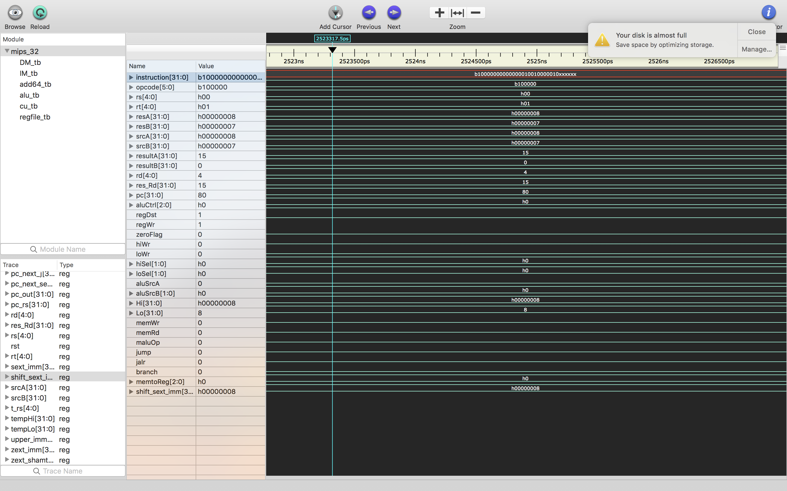

1. **Beq ( branch not taken)**
   1. Instruction : 32'b000100_00000_00001_00000_00000_000010;
   2. Output :

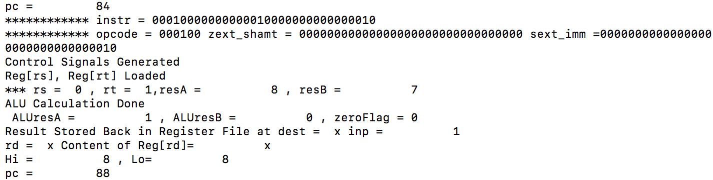

* 1. Waveforms:

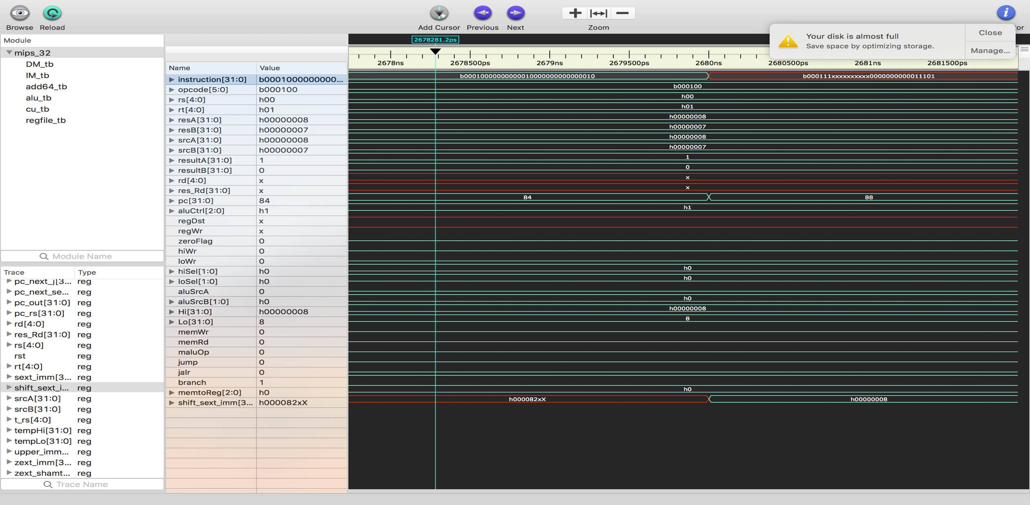

1. **J** 
   1. Instruction : 32'b000111_xxxxx_xxxxx_00000_00000_011101;
   2. Output :

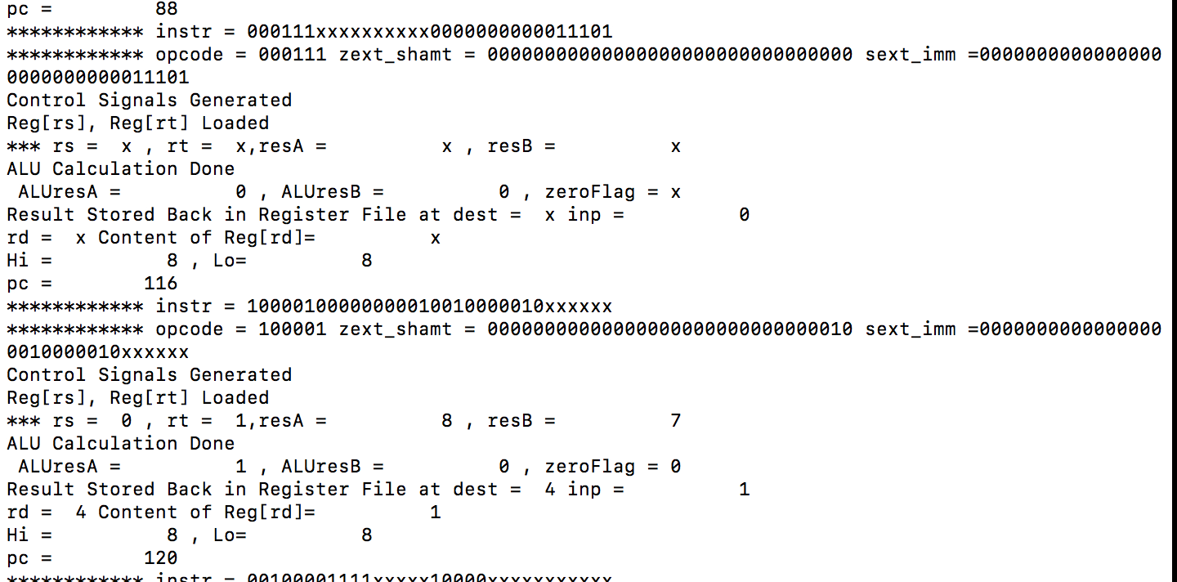

* 1. Waveforms

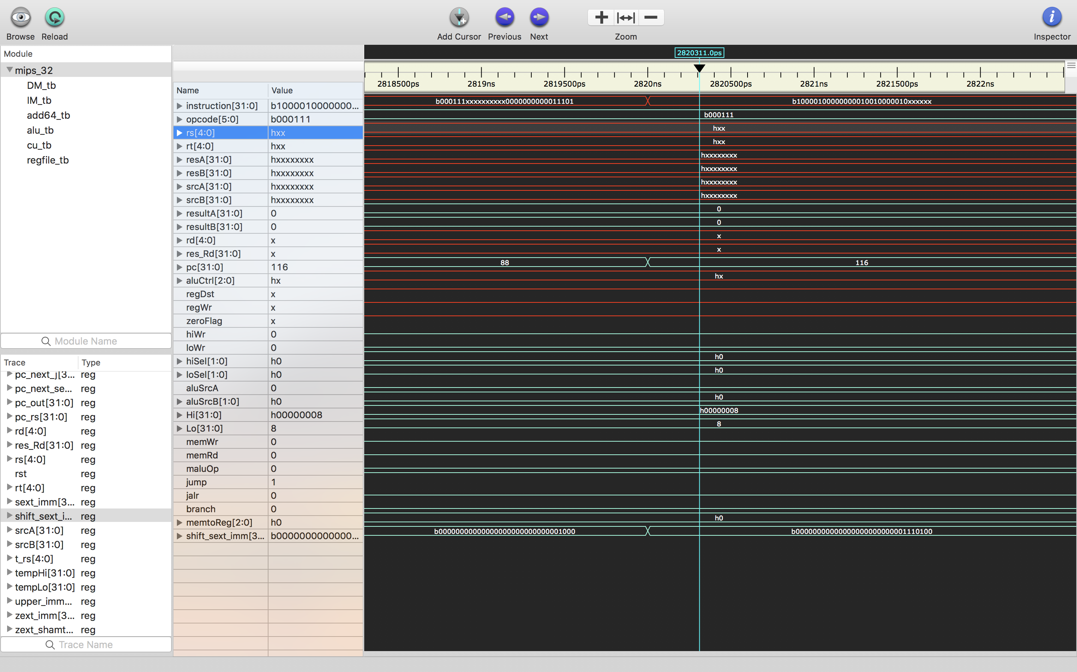

1. *Instruction after jumping – sub*
   1. Instruction : 32'b100001_00000_00001_00100_00010_xxxxxx;
2. **Jalr**
   1. Instruction : 32'b001000_01111_xxxxx_10000_xxxxx_xxxxxx;
   2. Output :

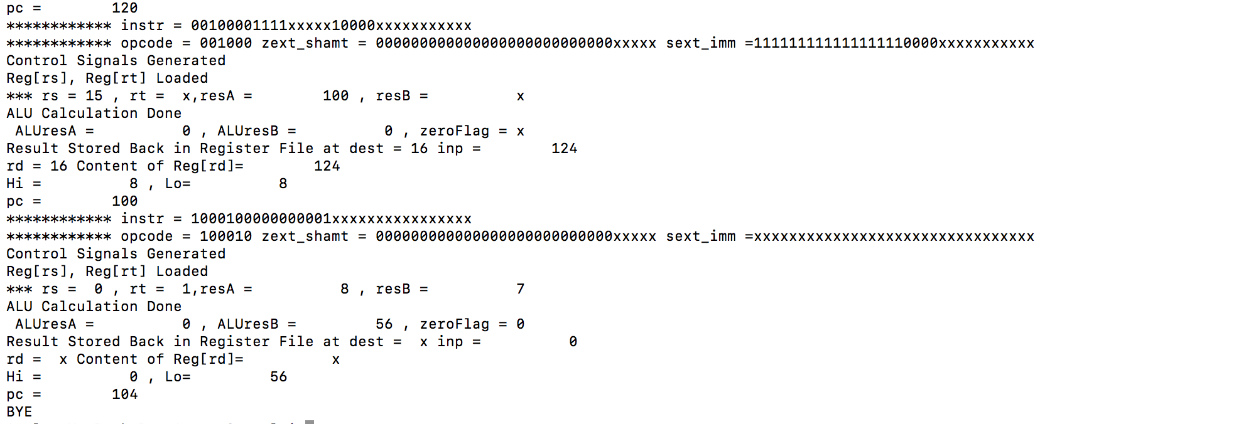

* 1. Waveforms:

(next page)

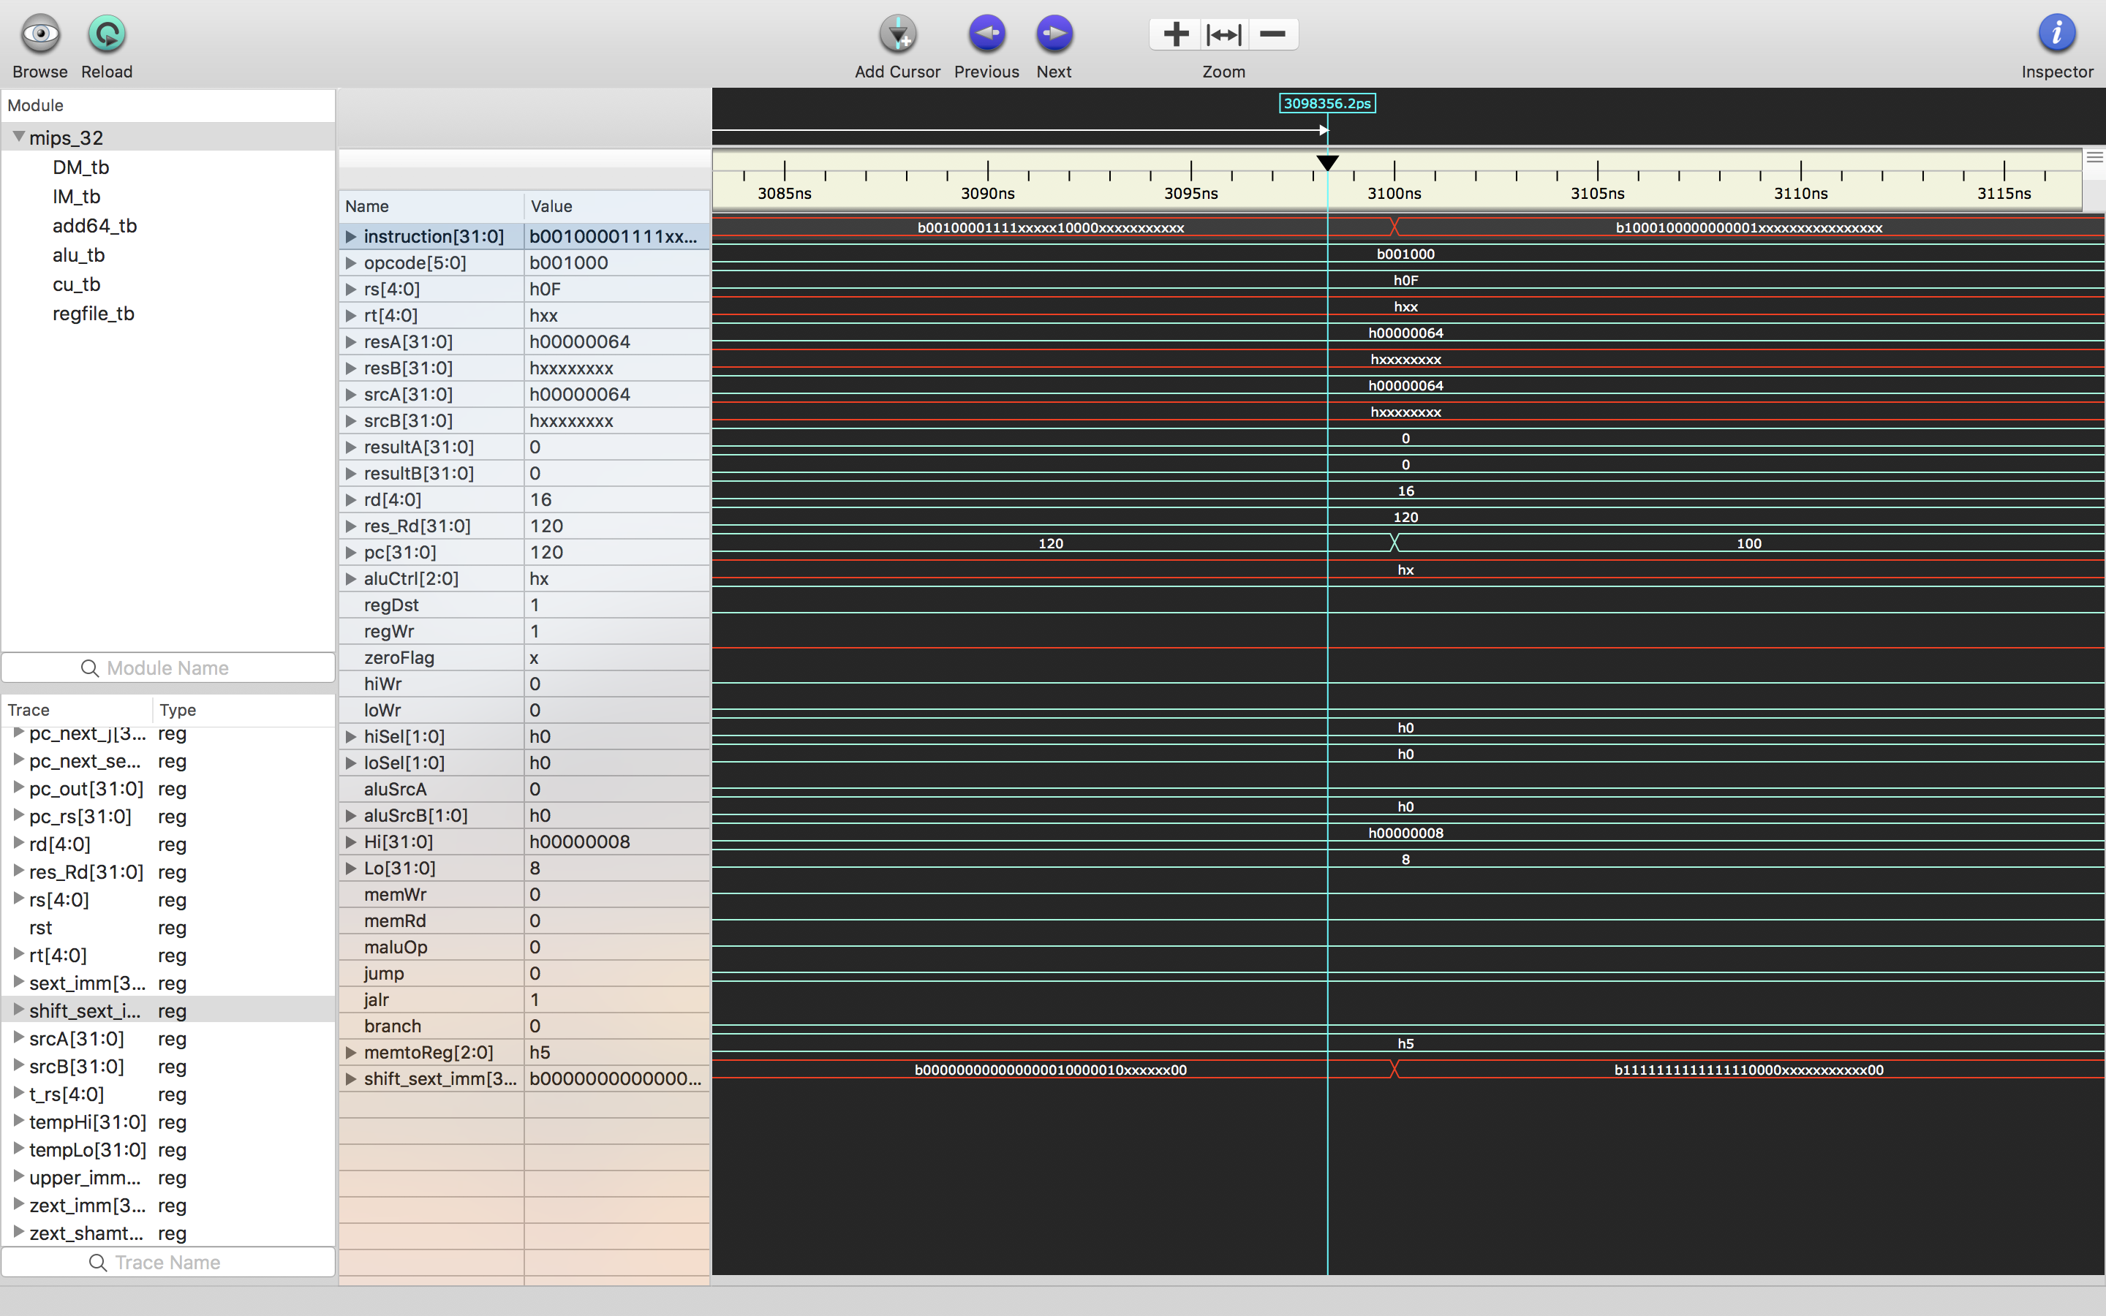

1. *Instruction after jalr – mul*
   1. Instruction : 32'b100010_00000_00001_xxxxx_xxxxxxxxxxx;
   2. Waveforms

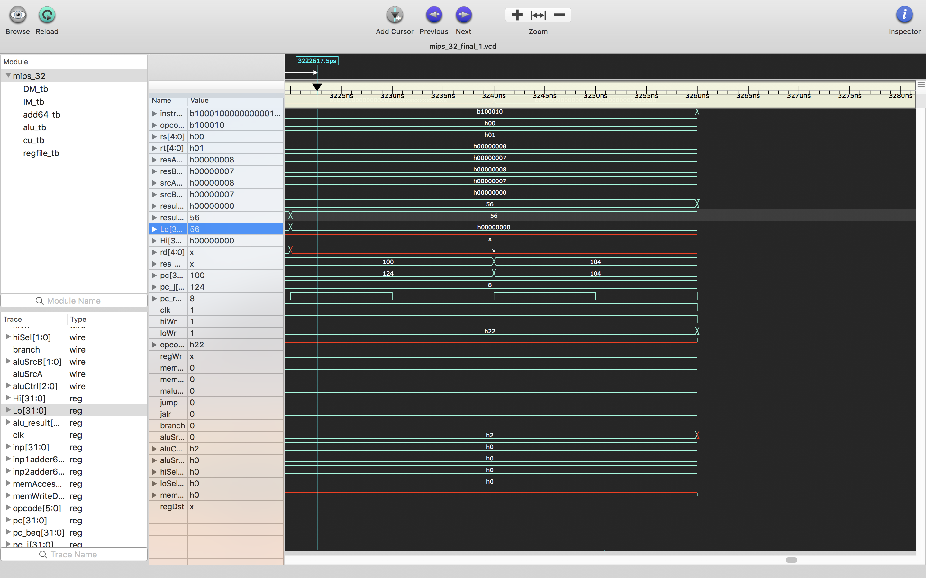

**Waveforms of All Instructions Together:**

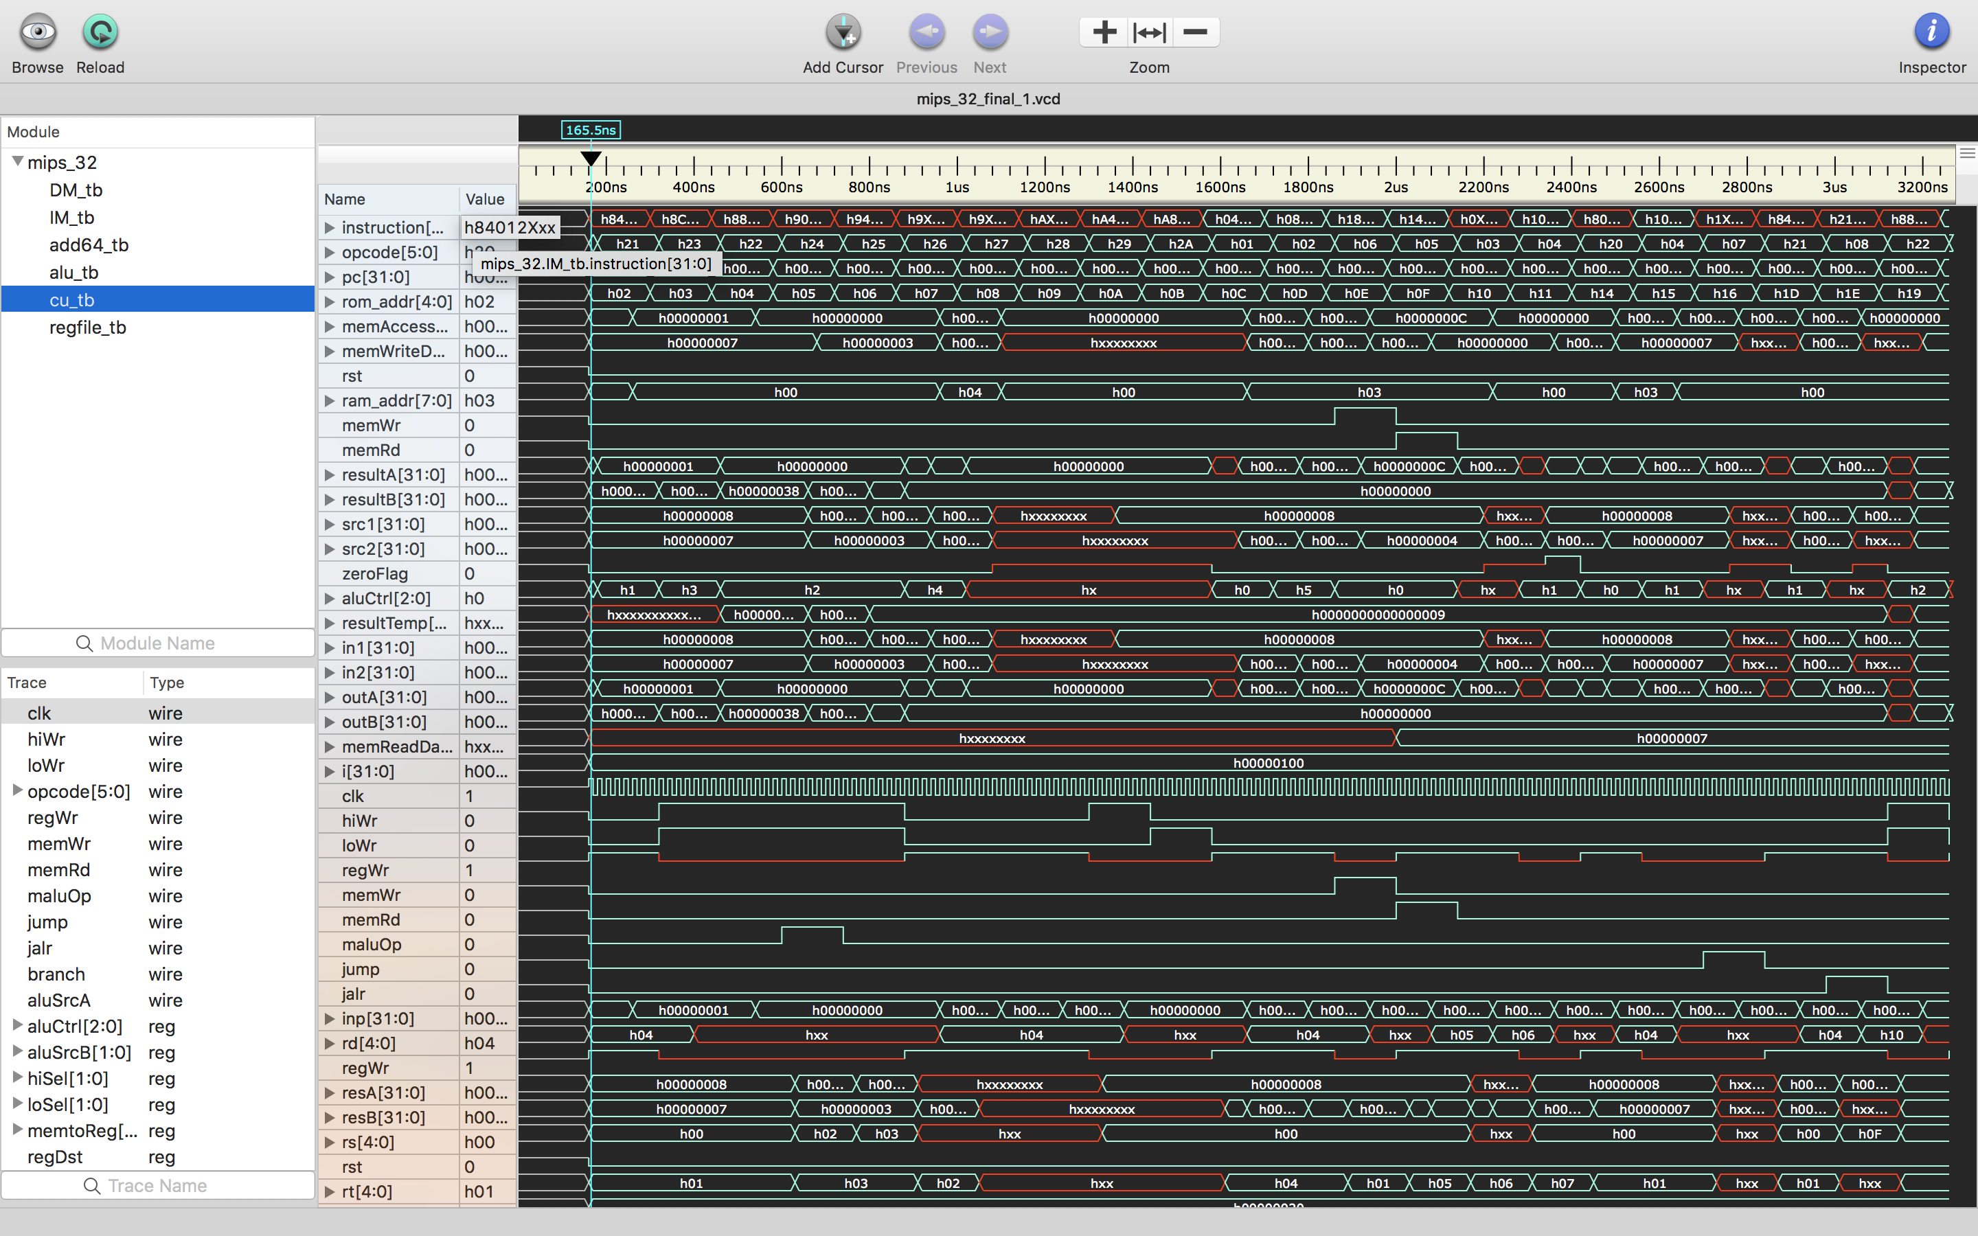

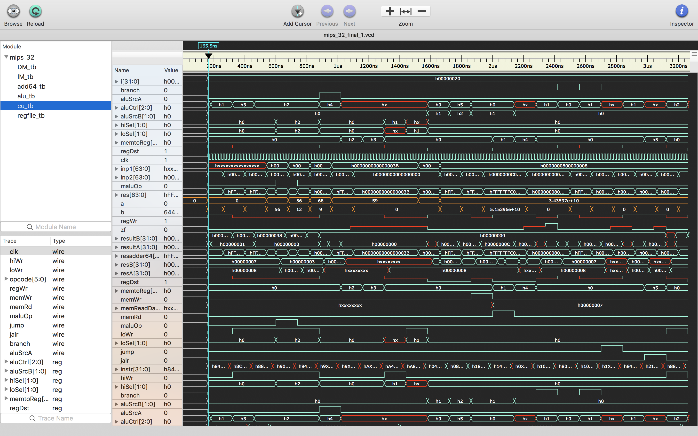

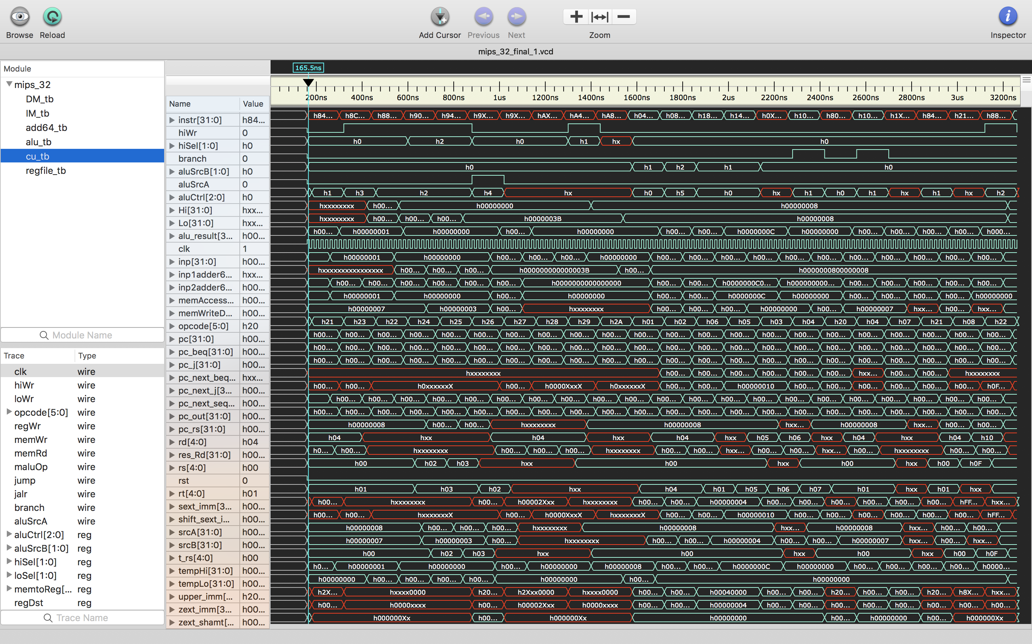

**Waveform of DataMemory**

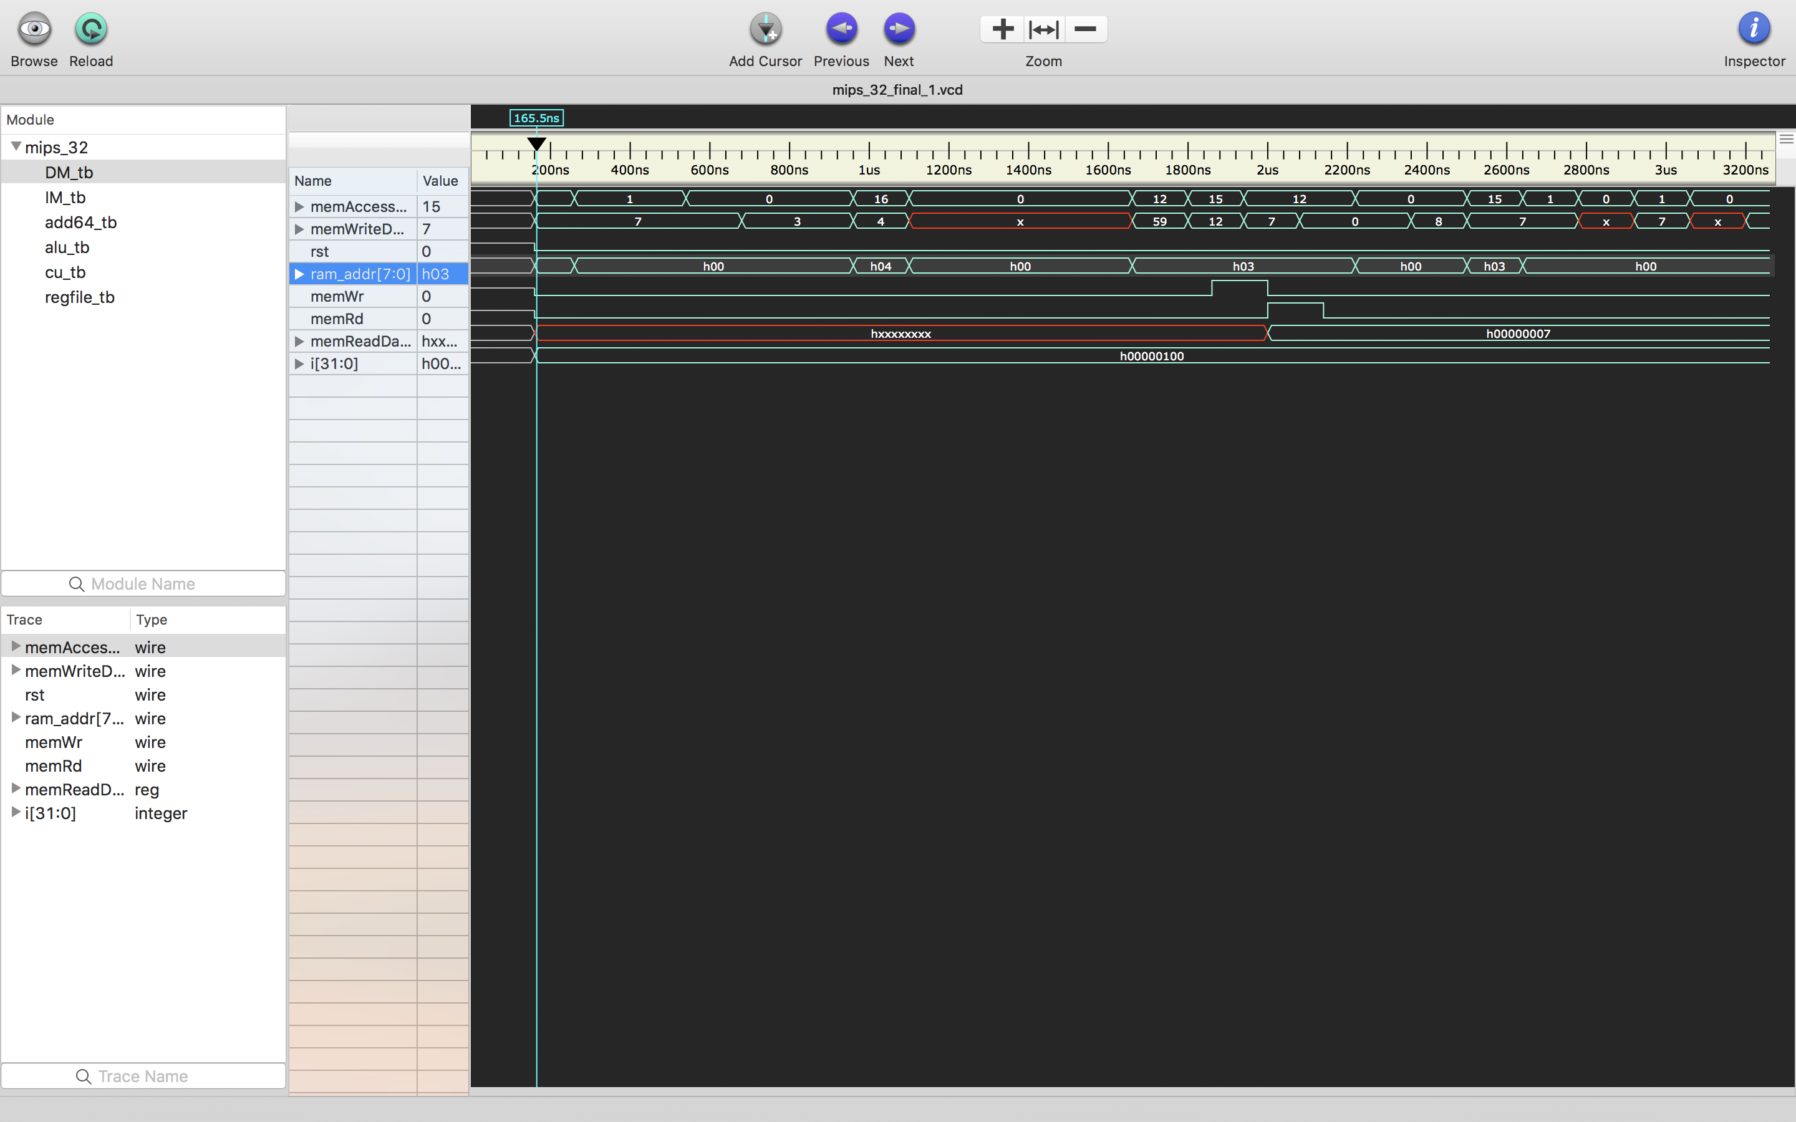

**Waveform of ALU**

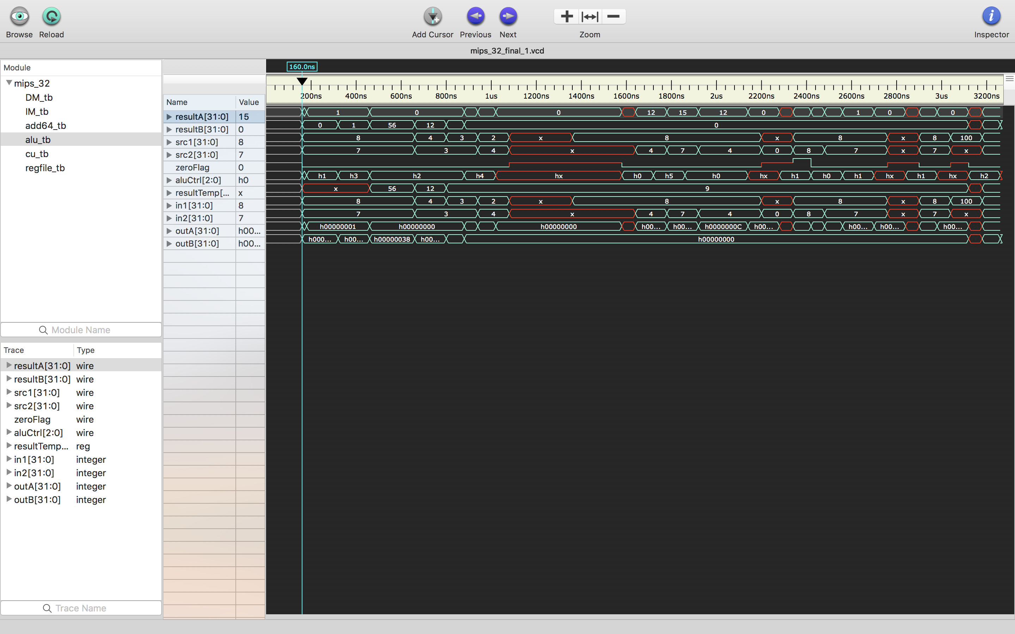

**Waveform of CU**

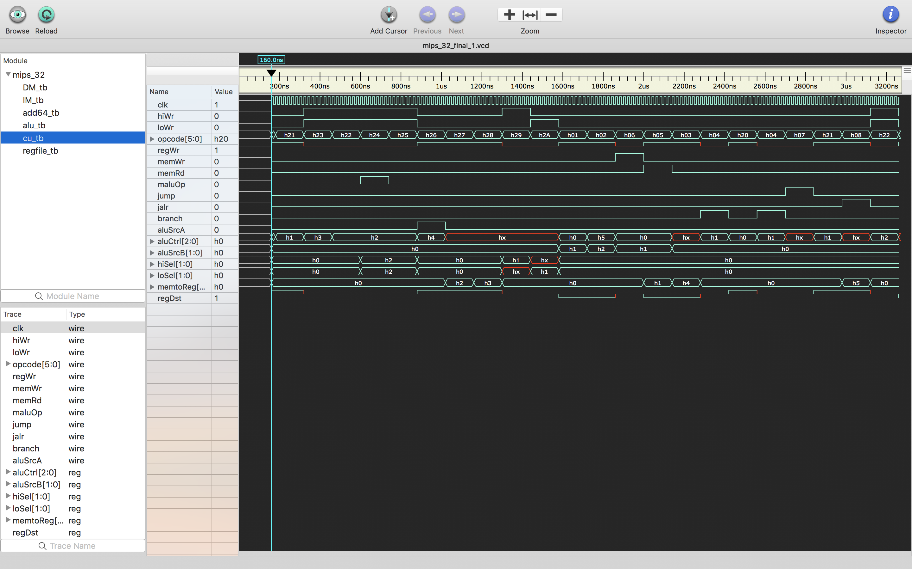

**Waveform of PC**

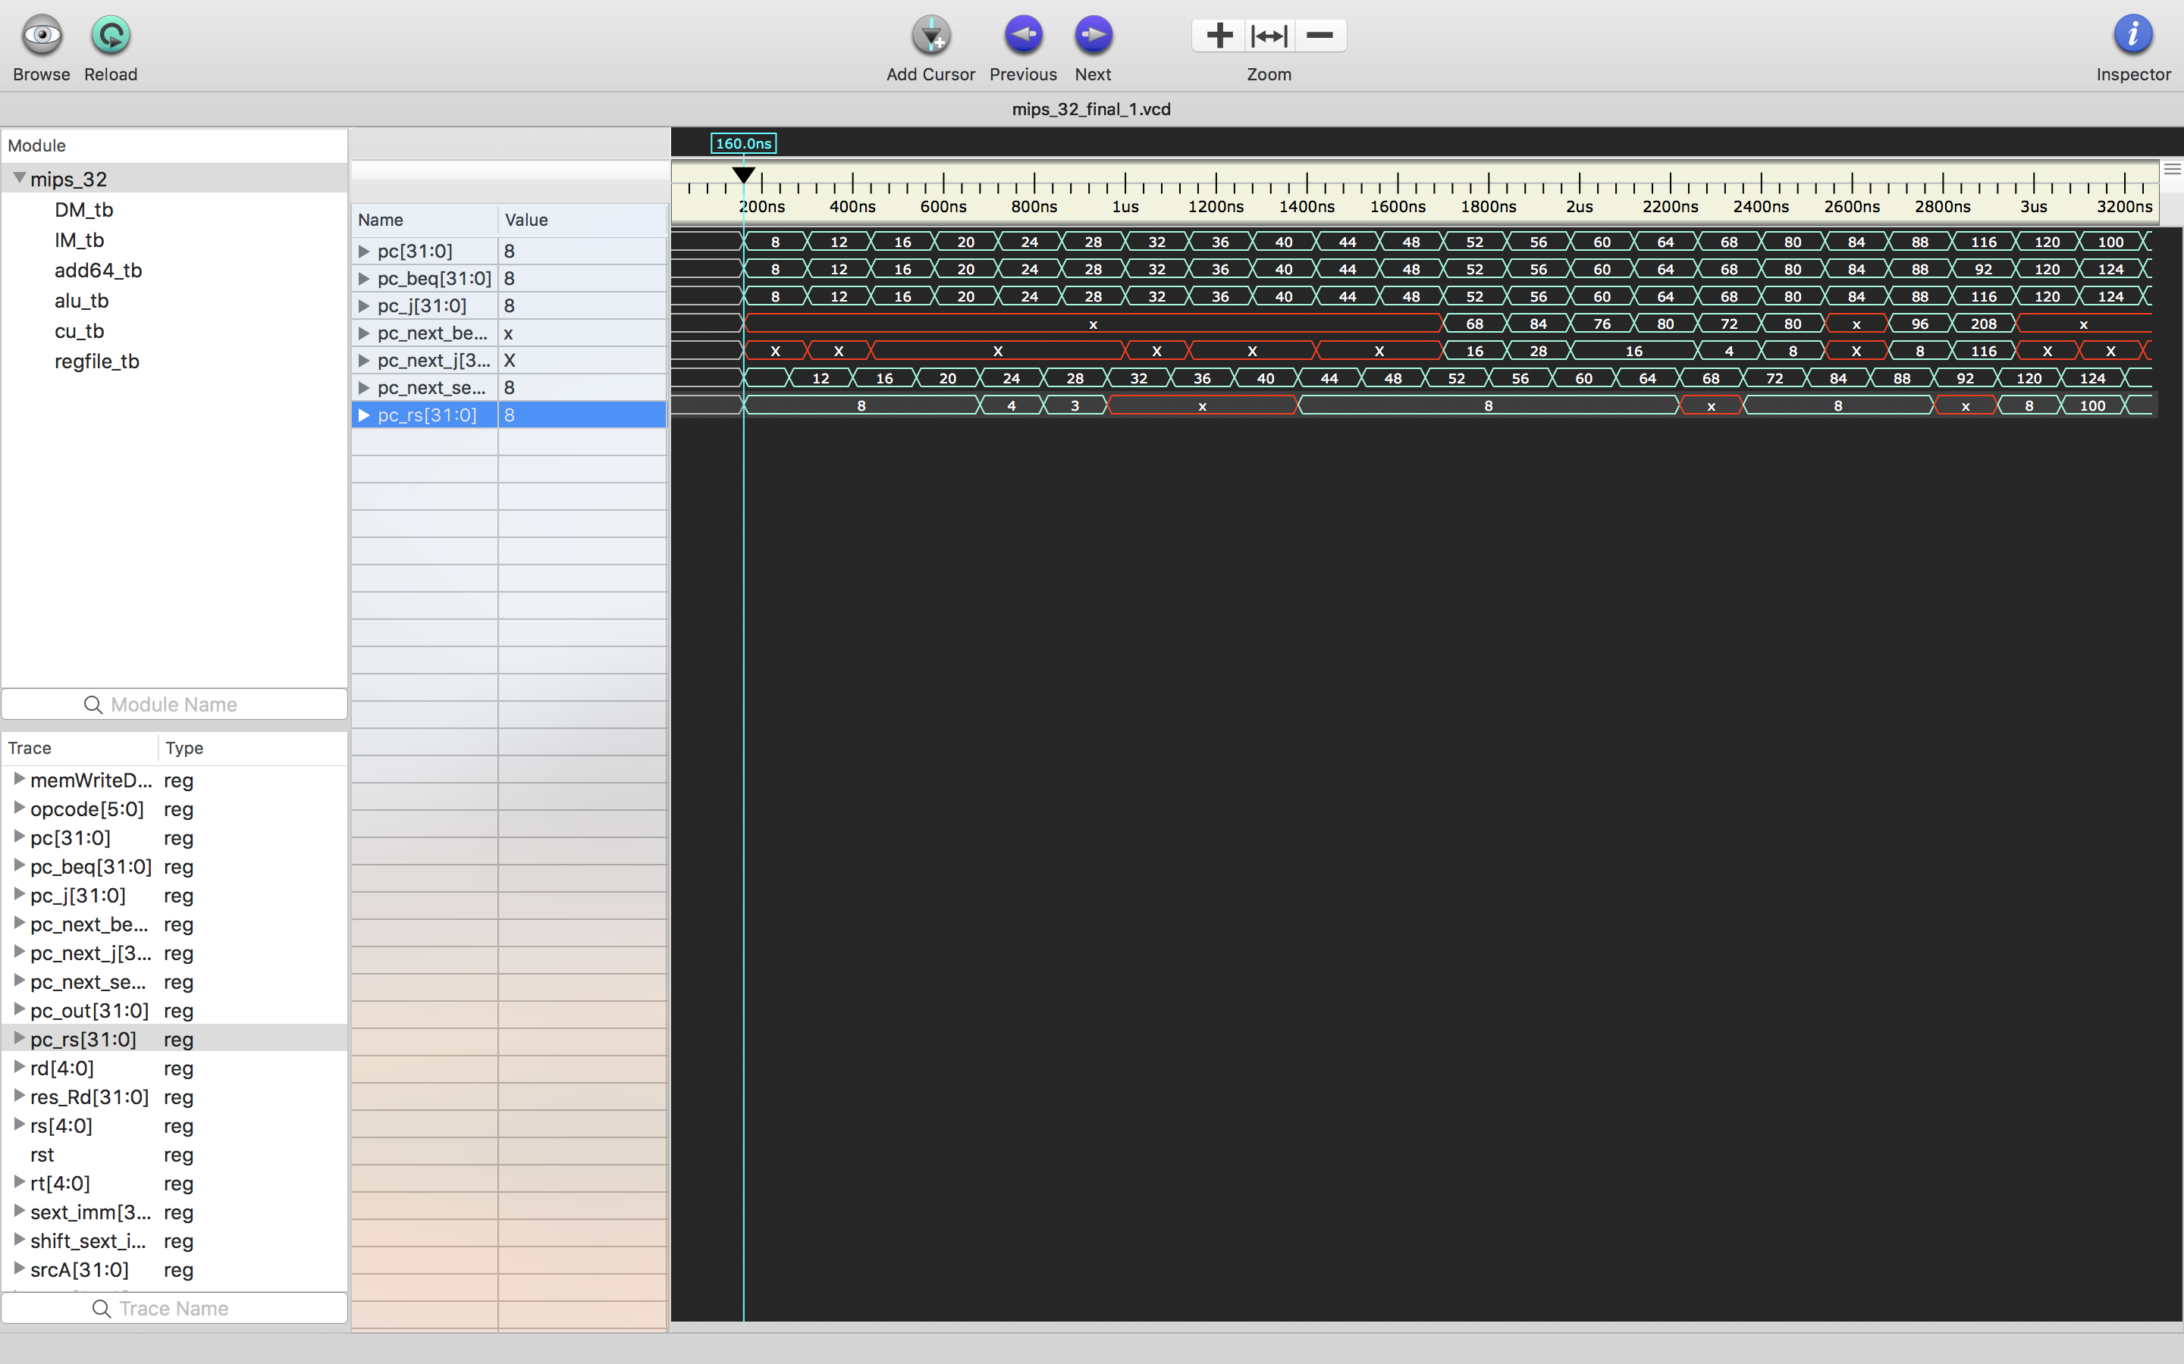

**Waveform of RegFile**

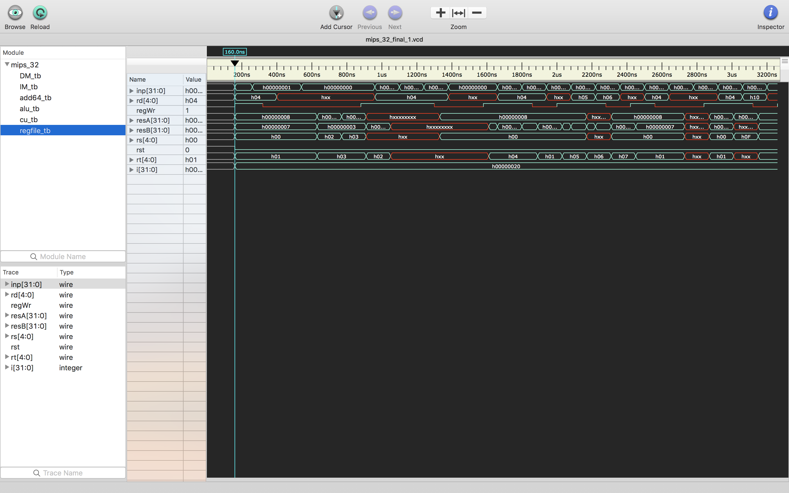

**Waveform of IM**

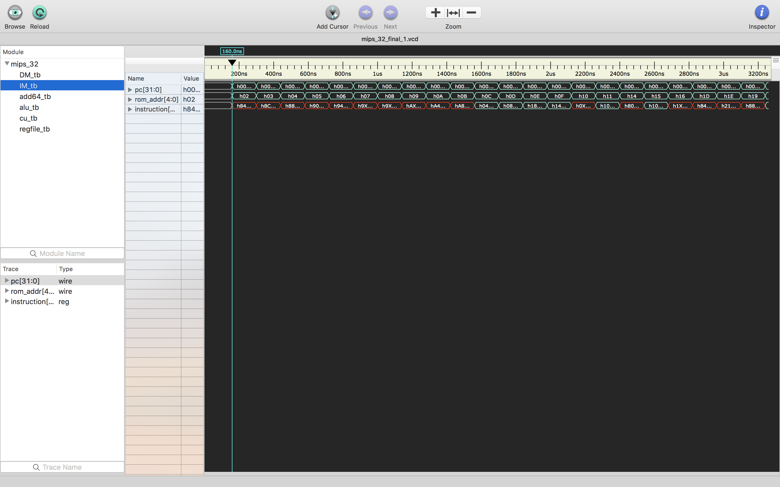

**Waveform of Adder64**

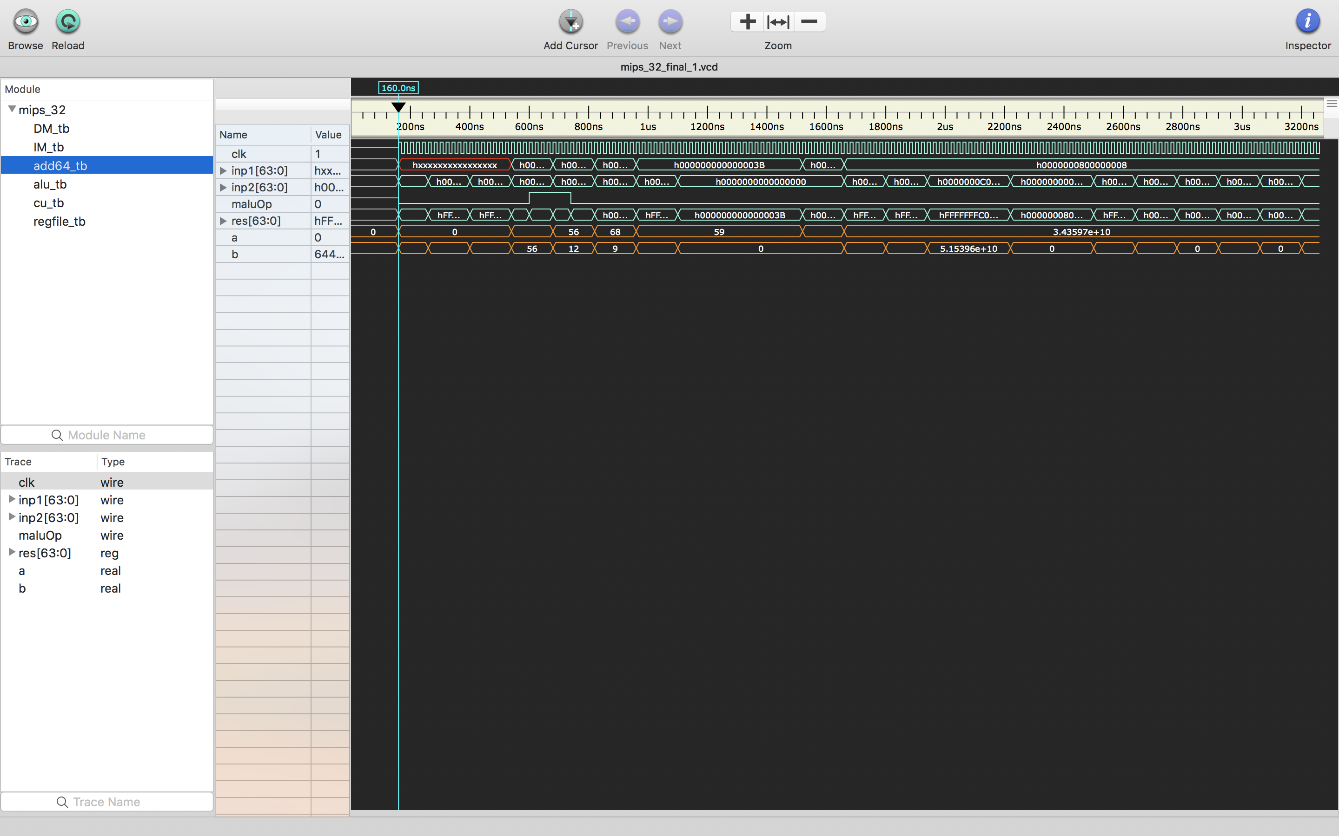

**Topmodule : mips_32**

